A Comparison of Professional Heavy Athletes.

Introduction
Heavy athletics consist of a series of events where competitors attempt to carry, toss or throw various objects. These games represent an ancient tradition which has become one of Scotland’s most attend sports. A feature of many highland games, these competitions feature both amateur and professional athletes. The goal of this project is to explore the relationship between the personal best score in the various events and how they contribute to one athlete being declared champion.
The Data
The data selected for this project is from the North American Scottish Games Athletics (NASGA) web page. This page contains a searchable database with results for the last 20 years.
Overview
For this project, the results for professional athletes in 2018 were selected. This data is ranked by individual and contains the personal best for each athlete in a number of events. A point value is associated with each event. A second data set containing the North American Records at the beginning of the season is provided. Finally, the algorithm used to determine rankings is included.
Summary Information
The athlete ranking data contains 72 individual records. Each record contains 20 fields. In addition to the Athlete name, rank and total points, each record contains the personal best information for 9 events. In eight of these events, the record distance is given as text data and the points for that event are given as a number. In the last event, the caber toss, only a score is provided.
The athlete data is augmented by a table containing the record distances for the eight events where a distance is given. Finally details on how to compute the total points for an event are provided. This includes a method for computing points scored in the caber toss.
Data Acquisition and Formatting
To obtain this data the following procedure was used.
- Locate the NASGA web page.
- Click on the Database link at the top of the page.


- In the Rankings box set the class to be Pro and the year to be 2018.
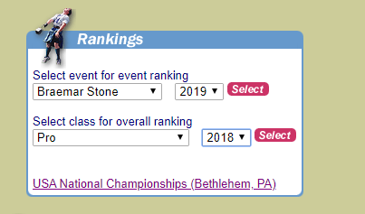

- Copy and paste the resulting tables into excel.
- Combine the first two rows to make a single column title line.
Data Dictionary
This data dictionary is generated from the column heading.
- Rank Ranking by total points
- Athlete Athlete name
- Total Points Sum of all points
- Braemar Stone throw Personal best in this event
- Braemar Stone points Points in this event
- Open Stone throw Personal best in this event
- Open Stone points Points in this event
- Heavy Weight throw Personal best in this event
- Heavy Weight points Points in this event
- Light Weight throw Personal best in this event
- Light Weight points Points in this event
- Heavy Hammer throw Personal best in this event
- Heavy Hammer points Points in this event
- Light Hammer throw Personal best in this event
- Light Hammer points Points in this event
- Caber points Points in this event.
- Sheaf throw Personal best in this event
- Sheaf points Points in this event
- WFH throw Personal best in this event
- WFH points Points in this event

Sample of the Data Set
Future Work

