Do the Lawn Before
Mom Gets Home!
Intense Lawn-Based Action
Dylan Whitehead
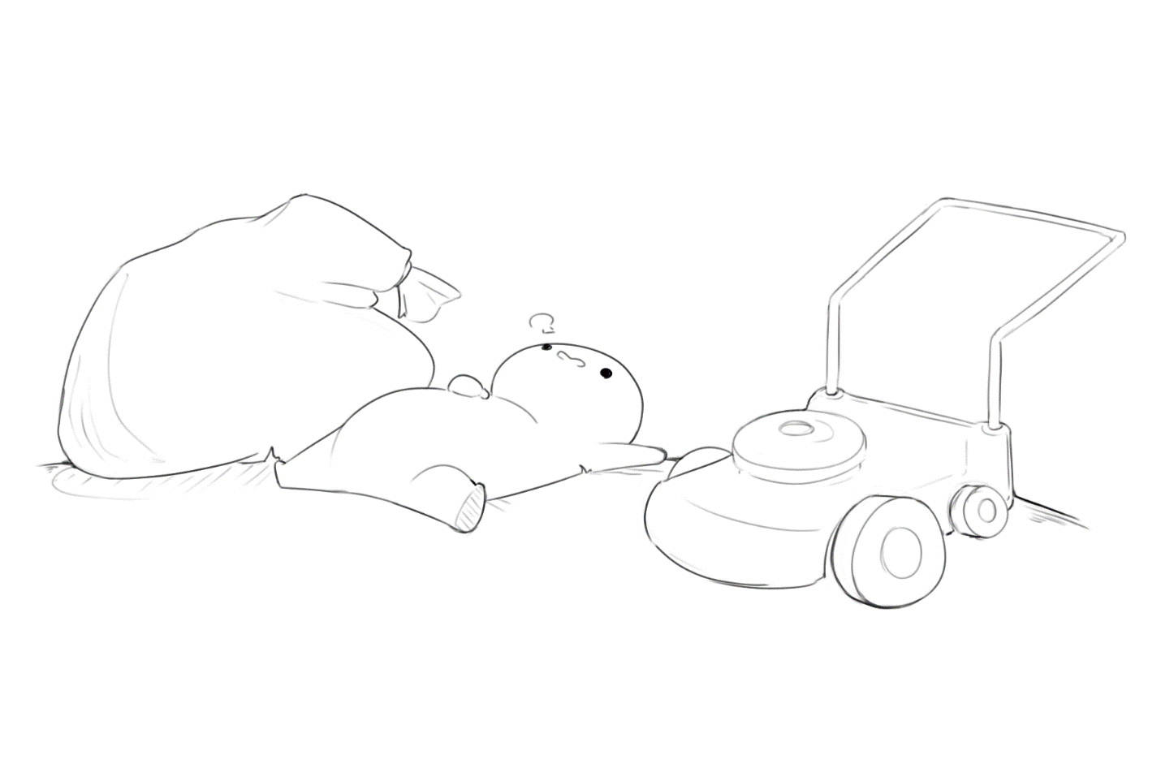
2/11/20
Group: TBD

Table of Contents:
1. Overview 1
1.1. Characters 1
1.2. Story 1
1.3. Mission Statement 1
2. Gameplay 1
2.1. Goal 1
2.2. The Game 1
2.3. Objectives 2
3. Game Mechanics 2
3.1. Basic Movement 2
3.2. Timer/Score 2
3.3. Pickup Item 2
3.4. Objective Display 2
3.5. Pause 2
4. Levels 3
4.1. Main Menu 3
4.2. Game Over 3
4.3. Mom’s House 3
5. Objectives 3
5.1. Objective Types 3
6. Required Assets 4
6.1. Characters 4
6.2. Buildings 4
6.3. Lawn 4
7. Optional Requirements 4
7.1. Lawn Hazards 4
7.2. Weather Hazards 4

- Overview
  - Characters
You: You are the chosen one. Unfortunately, the thing you were chosen for was yard work. Lame. Well instead of doing all that stuff you played video games all day. Now, mom just called and she’s saying she’ll be home in what, 90 seconds!? Aw jeez, get out there and get going!
Mom: Aw jeez, talk about a real box of rocks. You love your mom, any good boy/girl does. But let’s be honest here kid, she’s got a dark side that nobody should ever have to face and unfortunately for you the one thing she can’t stand more than anything else is the smell of uncut grass and week old pizza boxes in the driveway. You would do VERY well not to upset this lady!
Dad: Alright, listen me and the other kids have been talking and, well… Alright I’m just going to say it, we think your dad is a phone. There. It’s done. It’s out in the open for EVERYBODY now! I don’t know how that makes any sense biologically but that is the only conclusion you have left us with. I mean seriously, how come ain’t nobody ever seen him around before? We just see you talk to him on that old landline grandma forgot to throw away. Anyways, maybe you could ring him up? I mean, he must have been a kid once, maybe the ol’ pops will help buy you some time!
  - Story
You got nobody to blame but yourself, you know that? You sat inside playing those VIDEO GAMES all day and now mom’s calling you up and saying she’s down the street with green beans and lemon pops and you didn’t even start those dang chores. Well, what are you waiting for?! Get out there and do the lawn!
  - Mission Statement
The goal is to create a time-based 3D platformer where the player needs to complete a random series of tasks within the allotted amount of time. All these tasks are inherently time consuming, so the player needs to quickly adapt and form a plan for getting them all done. This means the game is much more focused around completing these tasks “as much as possible” rather than outright doing them all completely. At the end, a score will be assigned based on the percentage complete for each task that will determine the ending grade the player gets.
- Gameplay
  - Goal
Create a constant state of stress for the player as they are desperately trying to complete tasks fast enough to get a good grade. This should be emphasized in every aspect of the game including but not limited to player character animations, sound effects, timer presentation.
  - The Game
The game can best be described as a frantic task-completion simulator. The player is placed in a level and given a very short amount of time to do otherwise menial tasks. All the player knows is that these tasks are related to lawn-maintenance. While these tasks are seemingly easy to complete, there are a series of hazards interrupting the flow of gameplay triggering in regular intervals to undo progress the player has made and create new problems for them to fix. These hazards can be anything from weather-related effects like rain or snow, or something totally unexpected like a trash truck flying past your house leaving garbage bags everywhere. Coupled with the strict time limit, these hazards become a serious challenge and it’s the goal of the player to try and get the yard as clean as possible despite these hazards in order to get a good score.
  - Objectives
A list of 5 objectives will be assigned whenever the player starts the level. These should be decided randomly so to incite replay value. These objectives will each fit in to a category, discussed in more detail later in the Objectives section of this document, that should be different enough to not feel like they are just repeating the same processes. To make sure the player doesn’t get too many objectives of the same category, the randomness should be skewed so that objective categories are all represented. All these objectives should always have a progress meter displayed to the player and should have a visual indicator if the player has completed them fully.
- Game Mechanics
  - Basic Movement
The movement of the game ultimately just needs to support moving in a 3-dimensional space at a fast-enough speed to make the player appear frantic. Basic movement controls supplied through the engine can be utilized but should be modified to fit the speed of the game.
  - Timer/Score
A timer displaying how much time is left until the end state is reached should always be displayed to the player. This timer should facilitate the frantic pace of the game and not just be a static countdown timer like what the engine provides as a default. Animation, rotation, color, and font should all be used to represent the feelings of the player as the timer counts down.
  - Pickup Item
The player should be able to pick up various items while walking around. This pickup functionality will be used in various objectives but should ultimately be the same for each. Whenever a player presses a key and is next to an item, that item is updated so that it now “belongs” to the player. This player will then drag the item behind them and will throw the item based on that item’s weight.
  - Objective Display
The objective display should be a list that is populated randomly every time the player starts a level.
A display showing all the objectives for the level should be displayed to the player at all given times. A progress bar should be displayed with the objectives, showing how far along the player is with its completion. When an objective Is completed fully, a visual indication should be present showing that there is no more to be done for that objective.
  - Pause
A pause function should be implemented that stops all currently running functionality to stop until the player resumes play.
- Levels
  - Main Menu
The first level should be a simple UI that the player can use to both start and exit the game. This screen should be simple and set necessary initialization values for the player controller if need be.
  - Game Over
When the player finishes a level, they go to the game over level which then either allows them to go back to the main menu, or quickly replay the level they were just on to try to get a better score. An image should be displayed based off how well the player performed. The grading scale will go as follows, with an appropriate picture pertaining to each:

A | 90 – 100%
B | 80 – 89%
C | 70 – 79%
D | 60 – 69%
F | 59% or lower

  - Mom’s House
The main level of the game. This will be the primary play area for the runtime of the game. This map should be open enough so that objectives do not spawn too close to each other but not so large that simply walking to objectives becomes a chore. Many assets will be needed to be created in order to decorate the level which are detailed section 6 of this project document.
- Objectives
  - Objective Types
Objectives are categorized in types: Timed interactions, carry/pick-ups and drag-items.
Timed interactions require you to walk up to something and hold a button for a set period.
Carry/Pick-ups require you to walk to an item, pick them up, and usually place them somewhere else on the map such as outside the lawn or at a garbage can.
Drag-items are a special type of objective that require a player to pick up and use an item. An example of this would be a lawn mower or a rake, where the controls change to that specific item, they are holding rather than the standard controls.
- Required Assets
  - Characters
The playable character will need to have a skeleton rig, texture sheet, and three 3d animations made in Maya. These three animations should be an idle pose, a walking pose, and an item pickup pose.
Specific endings should be created that display at the end of a level based on the player’s score. These should be 2-dimensional drawings not unlike something you would see in an arcade game. The style of the art is completely open.
  - Buildings
One or two buildings will need to be modeled properly, though no animation will be necessary. These can be repainted and repurposed as needed.
  - Lawn
Many small assets will need to be created per the objectives. Refer to the objectives section of this design document to get a full list of what needs to be created.
- Optional Requirements
  - Lawn Hazards
If time permits, lawn hazards can be added to the game to add an extra level of stress to the player and to add replay value. These hazards can be anything from neighbors/drivers throw trash into your yard, raccoons coming to knock over the trash cans, other characters coming in and out of the house and knocking down props in the process, etc. This section, should it be deemed possible to be added to the final project should be expanded upon and a new version of the project document should be created and used from that point onwards.
  - Weather Hazards
If time permits, weather hazards can be added to the game as well. Like lawn hazards, weather changes can occur that have various effects on the player’s completion state. These events can be but are not limited to, rain making the grass regrow, mini tornados coming in to misplace props/trash, and snow making the ground slippery. This section, should it be deemed possible to be added to the final project should be expanded upon and a new version of the project document should be created and used from that point onwards.

