A basic how to on post processing affects
(A list of what each section does, mix sections together to get the best results)

  - Grab yourself a post processing volume
    - This can be done either directly into the world, put into a blueprint, or put onto a character
    - Next find the settings section, here is where the magic happens
  - Sections

  - White Balance
      - Temp
        - Raising it will put more of an orange tint on the world
        - Decreasing it will put a blue tint on the world
      - Tint
        - Raising it will put a purple tint
        - Decreasing it will put a purple tint
  - Color Grading
    - These lets you affect the contrast, saturation, Gamma, Gain, and offset
      - These modifications on done an xyzw scale
        - A good example of using the saturation is moving xyz all to zero to make the world around you go black and white
        - A good example of using the contrast is maxing out the xy to make everything colorful really pop out
        - Gamma ,Gain, Offset all kind of just put a colored filter over everything, will affect the looks of all colors depending on the mixture you use
  - Color Grading High,Mid,Shadow
    - These three section all are used for fine tuning the look of the what you want from the previous section
  - Film
    - This is where the real power of the post processing effects start
      - Film allows you to drastically alter how everything looks
        - Link putting a color tint that changes how everything looks even the color of the shadows
        - To letting you change how colors reflect off of other things with the channel mixing
  - Scene color
    - Scene color allows you to edit how things look as if it was a scene of tv
      - Using Grain jitter and Grain intensity to give that static look on the screen
      - Using Vignette Intensity to give to focus the players vision towards the center of the screen
      - Fringe intensity to make the world pop out and make it look like its shaking
  - Bloom down to Global Illuminator Include a lot of very technical things to do things like scene building for cut scenes, and manipulating light and how it looks
  - Depth of Field is probably the most powerful of the settings
    - It has three main methods
      - GaussainDOF
      - CircleDof
      - BokehDof
    - From what I can tell BokehDOF is Human vision
      - Messing around with the few settings it will allow you to access
      - You can cause things like not being able to see close,far away or at all
    - For GaussainDOF from what I can tell is to focus on two things
      - Making the player have trouble seeing from a very very long distance
      - Making the player only see a very faint outline of whats around them
    - Circle Dof starts to give you that pixel look on the world
      - This is done by setting the Aperture F-stop to 1
      - And the focal distance down in the 5-9 range
        - This causes the screne to get very block, and static like
    - Motion Blur
      - Nothing really fancy here
        - Make the world blury when it or you move
- There are to more important things
  - If you have multiple effects
    - You can give them a priority to pick which one gets to be shown the most
  - If you have want to trigger it off and on say via a blueprint
    - You need to modify its blend weight
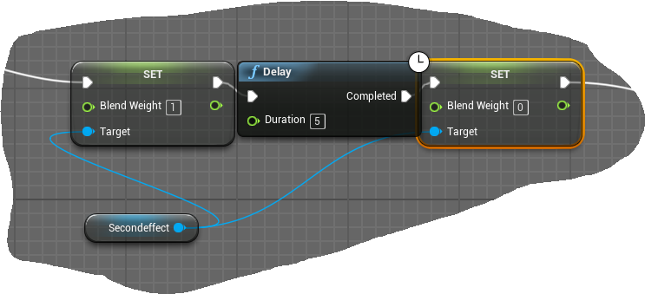
This above blueprint snippet sets the Post Processing effect to be on, and then five seconds late turn Off. There’s not really much with these things, they are very useful for creating cut scenes and things like that in unreal to produce staged areas with fake environments

*These are rather resource intensive on the machines in the lab for some of the effects, It doesn’t take much to make the machine skip a couple beats with one of these

