Multiplayer in Unreal
- Splitscreen
  - Enable in project settings
    - Maps & Modes
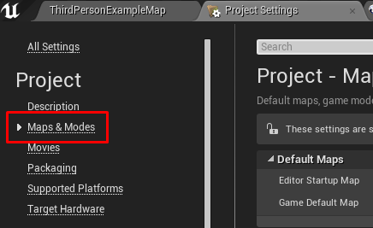
    - Check use split screen

  - Adjust local multiplayer settings (if needed)
    - MUST USE GAMEPAD’S FOR EACH ADDITIONAL PLAYER
      - Cannot have 2 inputs via the keyboard
      - Unless inputs are overridden or second actor is created
        - Must be an actor, cannot be a pawn
    - Skip assigning gamepad to p1
      - Do this to allow p2 to use the gamepad initially used for p1
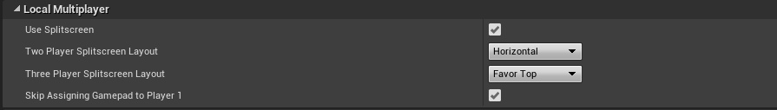

  - Example using a basic menu widget
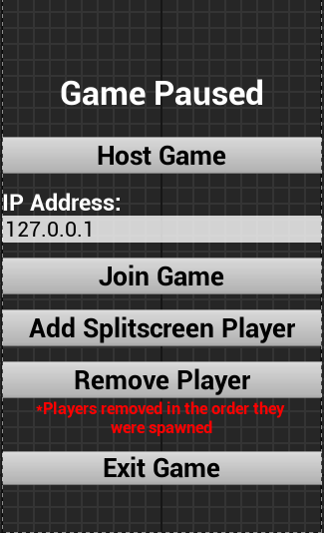
  - Any menu format can be used
    - 127.0.0.1 is set to the default IP for localized play
    - This is an editable text box for network play

  - Split Screen Button (can be a key or custom event)
    - Controller ID
      - Used to identify the ‘player number’
      - Player number is used to assign the gamepad to a player
      - -1 assigns the next available controller to the created player
    - Spawn Pawn
      - Allows the pawn to be spawned immediately or the next time a level is loaded
    - Keep track of players
      - Uses a game instance to record players, so it does not reset when a level is loaded
      - This is not needed, however it was implemented so players could be added and removed from the game accordingly
      - Also to make sure the host does not remove self from game
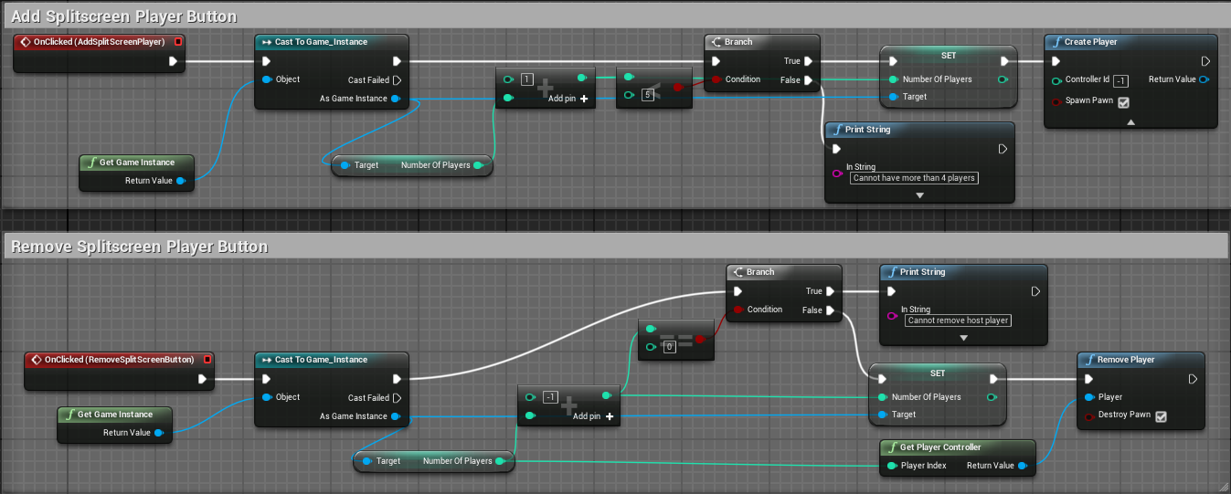
  - Add Player Start
    - Host spawns wherever you place your character
      - If no character is placed it will spawn at a player start
    - Spawns are randomized by default
      - Can be set but entitles creating spawn overrides with c++
    - If no player start is defined, player will spawn at (0,0,0)
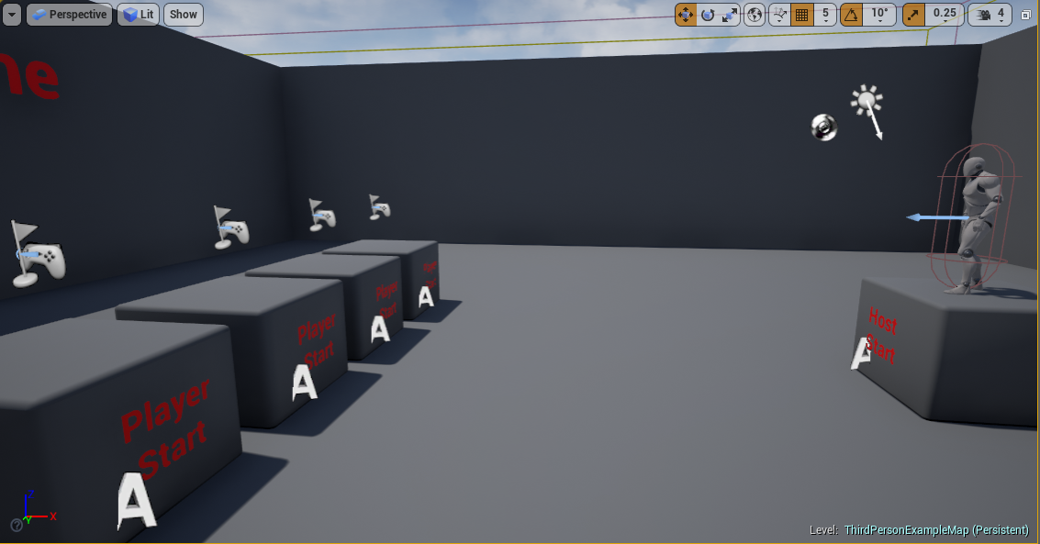
- Network Play
  - Hosting (can be a button, function or custom event)
    - IP Address
    - Open NetworkMap?listen
      - Allows player to open the network map (can be any level name) and opens the listen server for any players trying to join
    - Any player can host on their own IP Address
      - To host you must forward port 7777 to your internal IP as that is the port unreal uses to communicate
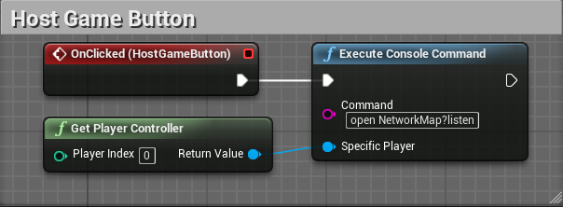
  - Joining
    - IP Address
      - Must enter host's ip address in the menu (i.e 127.0.0.1)
        - The open command is then executed with the given ip address as: “open 127.0.0.1”
        - This attempts to open the server with the ip address of 127.0.0.1
      - Host must be listening to accept the join request
        - If there is no host available the connection won’t establish
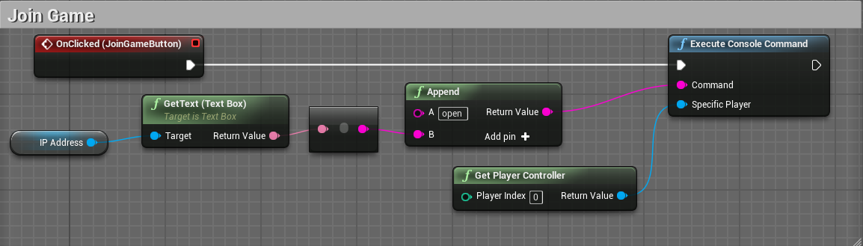

  - Set number of players
    - Drop down menu from play > multiplayer options
    - This is for local and network playing
  - Other options
    - Drop down menu > advanced options
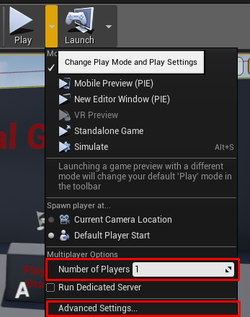
    - Number of players
      - 1 to 64
    - Server Game Options
      - Command line options that are applied to an executable for the game
      - For example:
        - -server allows to run the game as a server using uncooked content
        - -game allows to launch the game using uncooked content.
      - More info/commadns at: https://docs.unrealengine.com/latest/INT/Programming/Basics/CommandLineArguments/
    - Auto connect to server
      - Will auto connect to a server if the host is already running
      - If this is selected while testing locally, all players will spawn with the host in the local room instead of the networked room

    - Create Audio Device
      - Creates 2 separate audio devices for first two players on a client
      - For more than 2 players
        - Players will share audio devices due to cpu consumption
