Mouse Interaction by Jeremy Hanes

Enabling the mouse for use
If you are building from scratch you need to create a player controller, and check the boxes that allow click events, and show cursor. These options are under the class defaults section.
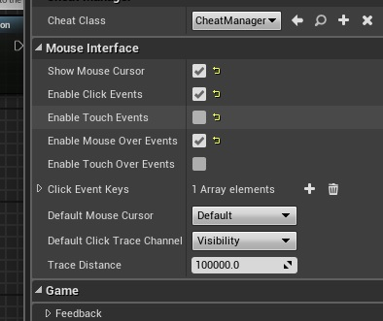
If you want the cursor without making an entire player controller, you can access it like this:
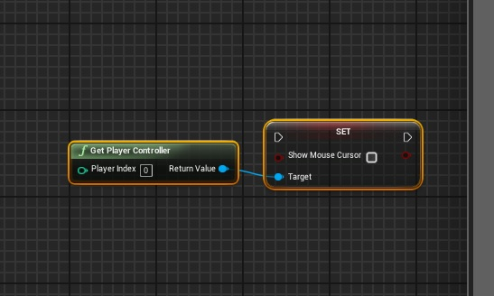
After activating the cursor and its events you can start using those to do different things. Some of the events that are included in the engine are the On Clicked, On Release, On Begin Cursor Over, and On End Cursor Over. You can access these by having an object and adding an even to it. After you add any of these events they work the same as any other event and can be used to many things.
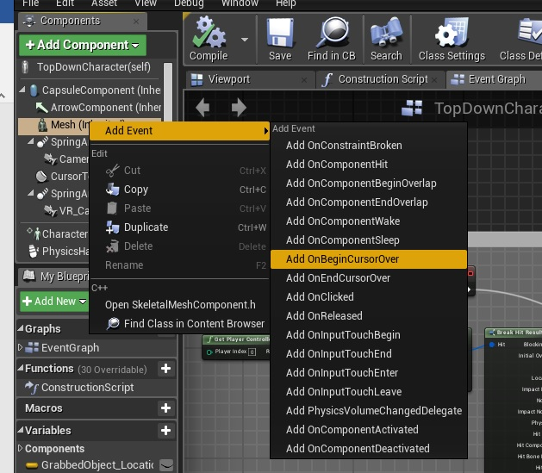

If you want to add event based on what button you are pressing, then you can add them by doing this;
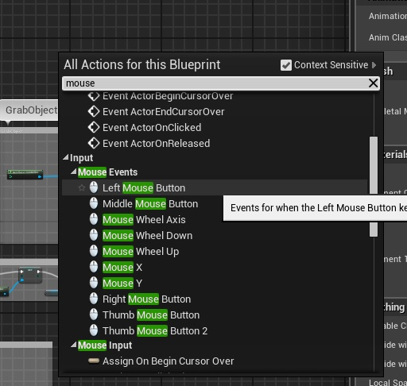
Or by adding an input action in the project settings.
One of the common things to use while working with the mouse is the Get Hit Result Under Cursor by Channel. This allows you to grab the location of your mouse in the viewport and the object underneath it.

Character Movement:
Character movement is fairly simple to do when using the mouse, there is a provided version in the topdown game preset. This is a compressed version with the stuff I did not require removed.
In TopDownController
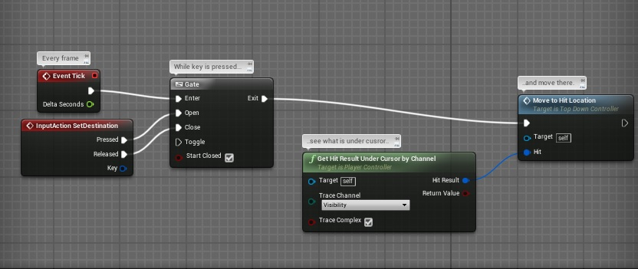
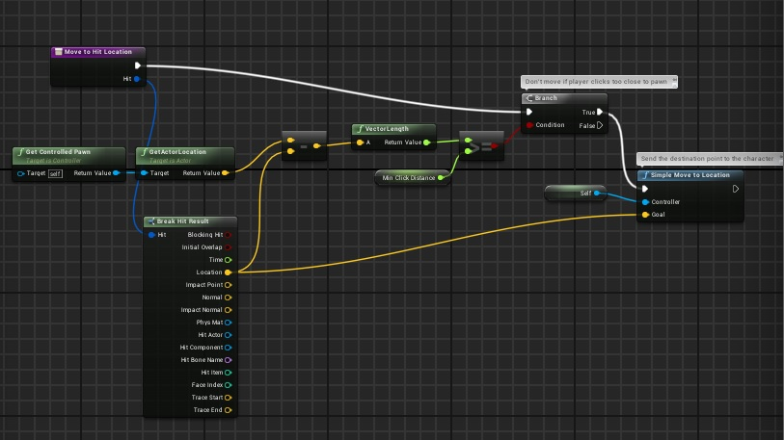
On a side note in order to use the simple move to location, a navmesh is required (just a simple drop and scale into the level)
Along with the character movement you can add things like decal components to place a texture on the ground where the cursor is, to do this you add the decal to the character and set its location based on the cursor location.
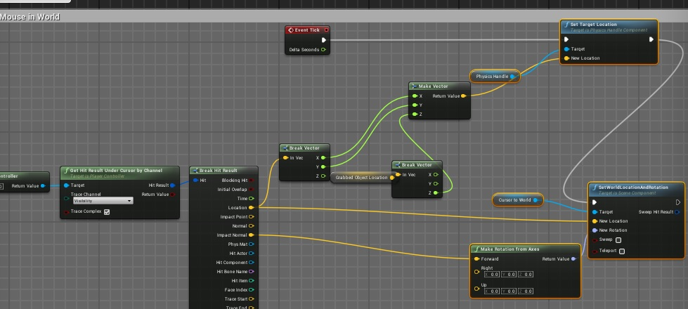

Grabbing And Releasing Actors in the game
First you need an actor that has the physics enabled, then you need to add a PhysicsHandle component to your character, the blueprint in the character looks like this
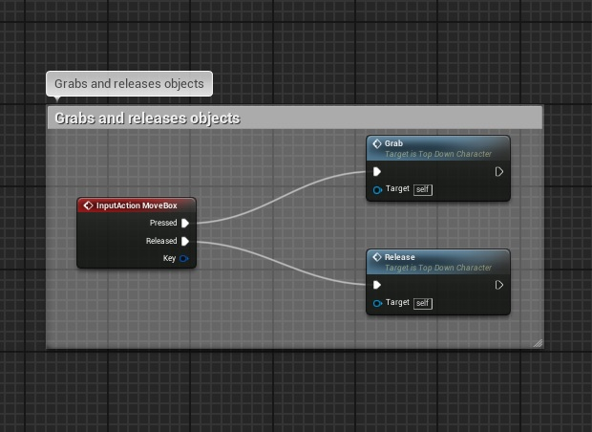
Note: the input action in this case is set to be the middle mouse button
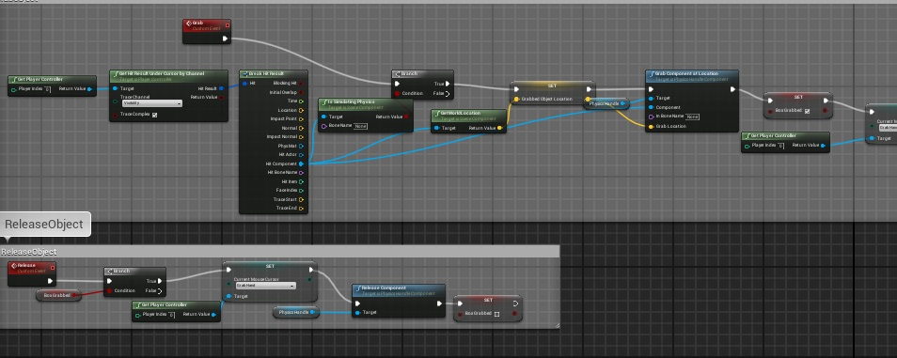

Swapping Characters:
To swap characters you need to have two separate character blueprints, which can be done by simply duplicating the first one. To actually swap the characters you need to set up something like this:
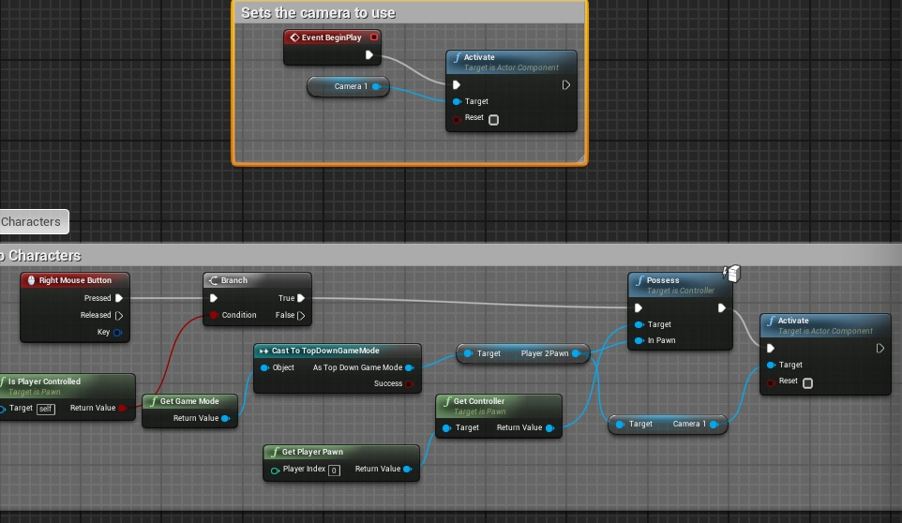
When you do this it is best to create references in the gamemode blueprint and to set the reference values in the level blueprint. The only difference between the characters will be that you need to change out which InPawn, and the camera to use.

Changing the cursor that is being used:
Changing the cursor is as simple as the blueprint below. Deciding when you want to change it is a little more complicated, but is still pretty easy.

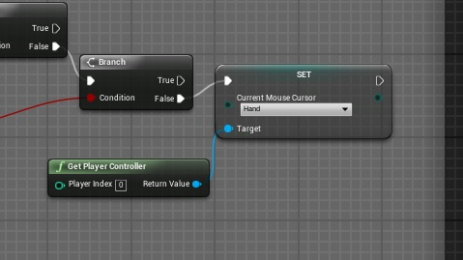
An example of is as follows (uses the grabbing and releasing to determine which cursor to use)
