Macros and Functions Libraries
Blueprint Function Library
Descriptions
- Blueprint Function Libraries are containers of functions to be used in other blueprints. They cannot contain variables, inherit from other blueprints, or be placed in levels. Changes to functions in a Blueprint Function Library will take effect without recompiling the client blueprints.
How to create a Blueprint Function Library (the following instruction are adapted from Unreal’s website for blueprint macro library. The links are at end of the document)
Blueprint Macro Libraries are stored in packages and can be created through the Content Browser like any other asset.
- In the Content Browser, click on .
- Select Blueprints > Blueprint Function Library under Create Advanced Asset from the menu that appears.
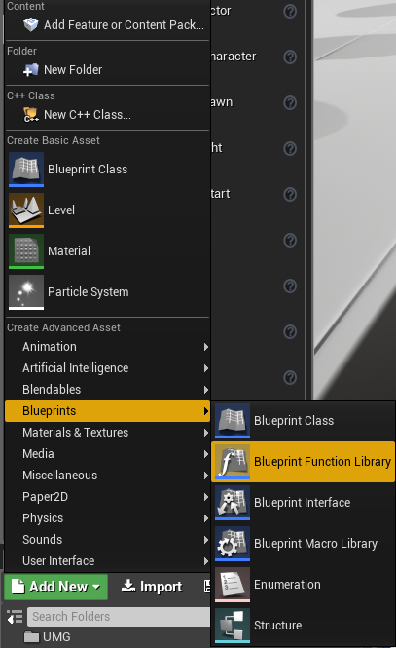
- Then open the new asset and create functions as you normally would.
- These new function are accessible across all class blueprints and level blueprints.

Blueprint Macro Library
Descriptions
- Blueprint Macro Libraries are containers of macros to be used in other blueprints. They cannot contain variables, inherit from other blueprints, or be placed in levels. Changes to macros in a Blueprint Macro Library will not take effect until client blueprints are recompiled.
How to create a Blueprint Macro Library (the following instruction are directly copied from Unreal’s website. The links are at end of the document)
Blueprint Macro Libraries are stored in packages and can be created through the Content Browser like any other asset.
- In the Content Browser, click on .
- Select Blueprints > Blueprint Macro Library under Create Advanced Asset from the menu that appears.
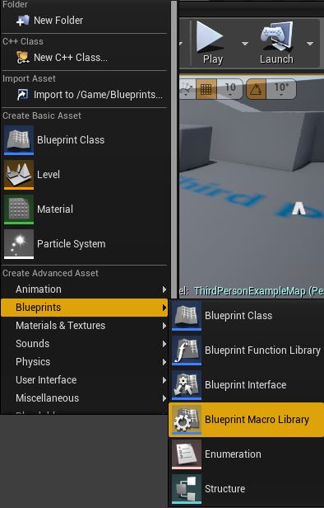
- Choose a Parent Class for your Blueprint Macro Library.
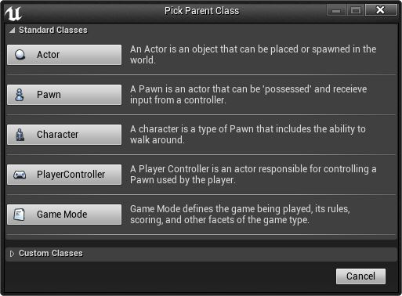
- Then open the new asset and create macros as you normally would.
- These new macros are accessible only in the chosen class blueprints or any child of the chosen class blueprints.

Links
- Blueprint Macro Library
- Macros
- Functions
Other Links
- Unreal Engine 4 101 Vol.1 Ep.1 - Navigating the Viewport, Snapping & Window Layouts
- Unreal Engine 4 101 Vol.1 Ep.2 - Important and Useful Settings
- Unreal Engine 4 101 Vol.1 Ep.3 - Game Project Start: Add Objects and Basic Blueprints
- Unreal Engine 4 101 Vol 1. Ep.4 - Construction Script, Inheritance and Object Oriented Programming
- Extra 1-Click Blueprint Nodes - Unreal Engine 4 Extend Editor

