First Inventory (simple)
The main widget blueprint
This is just a border with a uniform grid panel on it
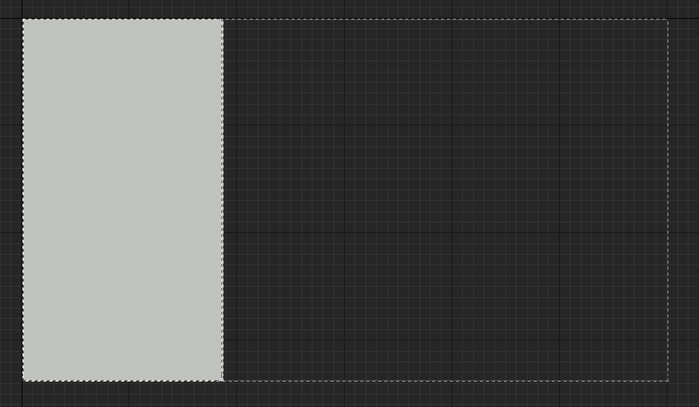
Variables
Mychar type ThirdPersonCharacter (reference to player’s character)
IsVisible? Type boolean (checks if the widget is visible on the screen)
List items function
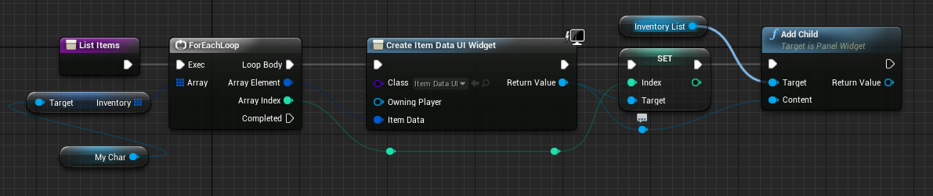
Update list function
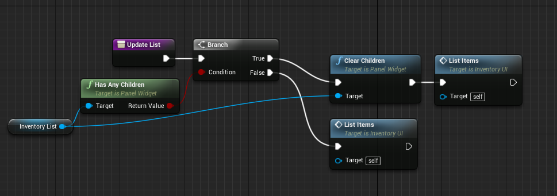
Show widget function
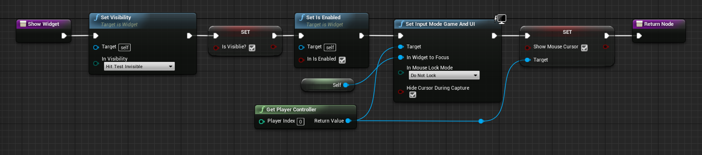

Hide widget function
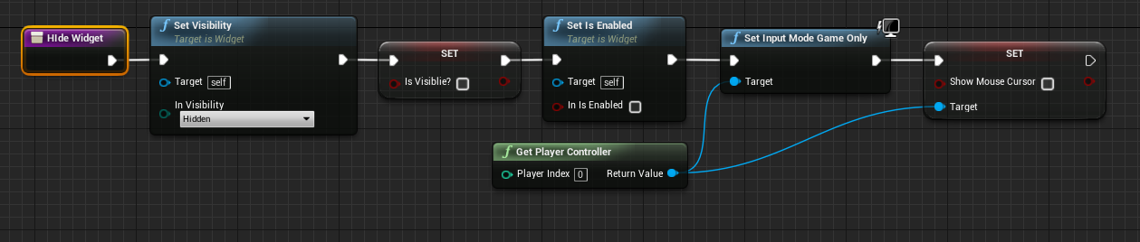
Event graph
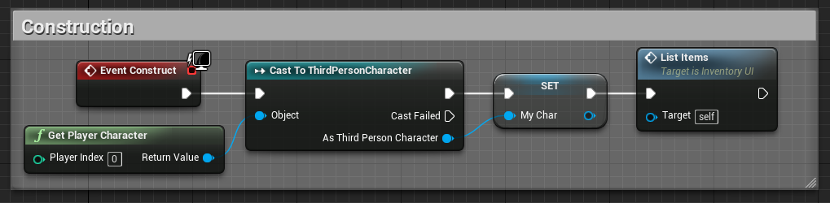

The child widget blueprint
A button with an image and some texts
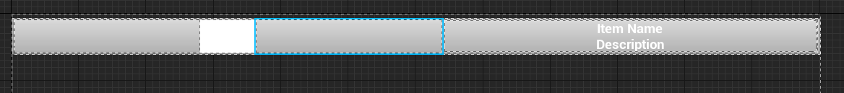
Variables
ItemData type ItemStruct (the item that is stored in the slot)
Index type integer (used to index items in other blueprints)
Update widget function
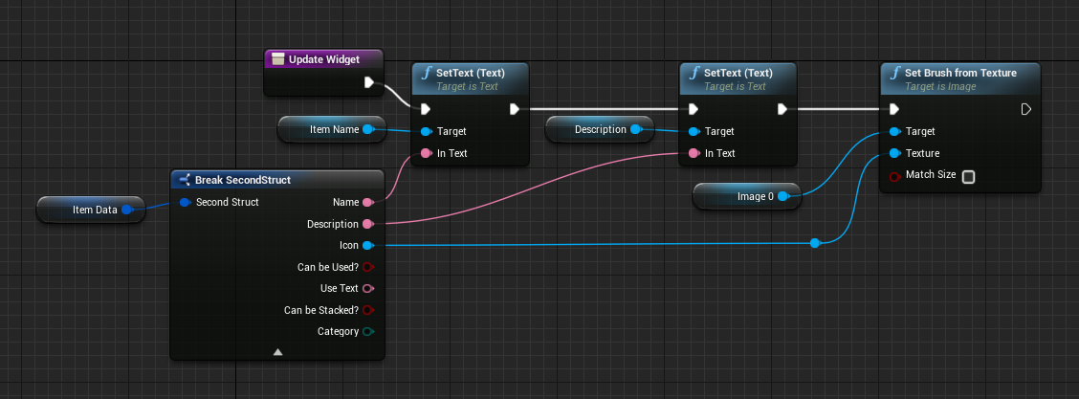

Event graph
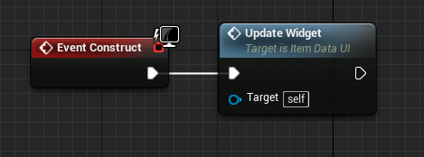
Hotbar
The main widget blueprint
The hotbar is just a uniform grid panel that is scaled to fit content(too small to have an image)
Variables
NumOfButtons type integer(the number of slots on the hotbar)
PlayerHotbar type integer array
Update hotbar function
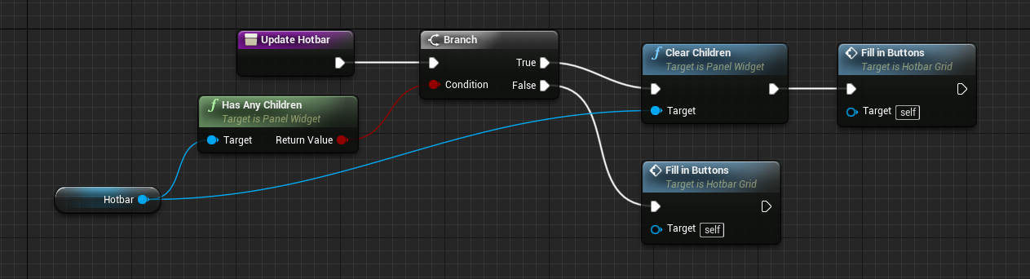
Fill in buttons function (3 images)
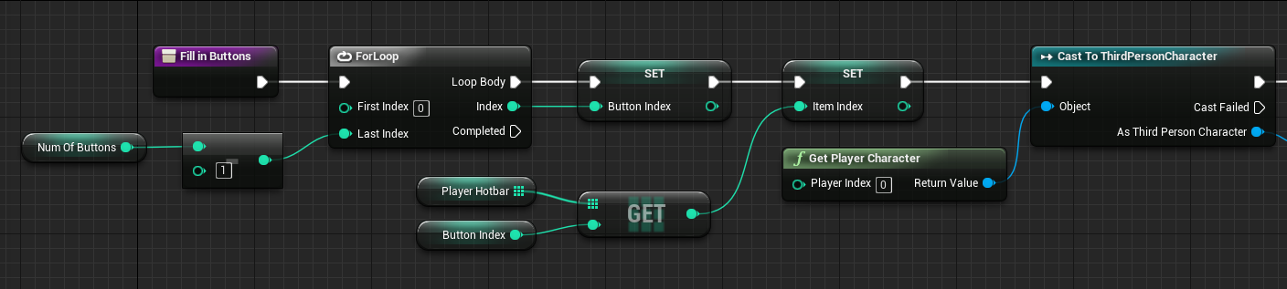
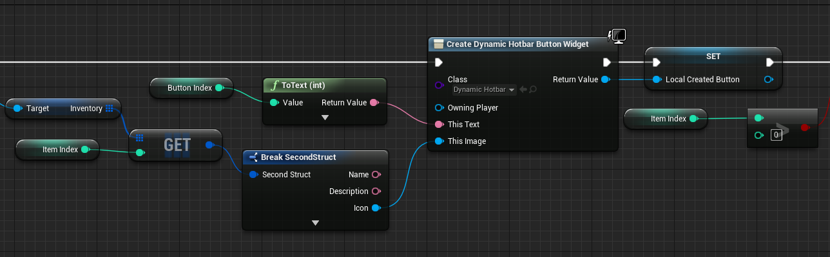
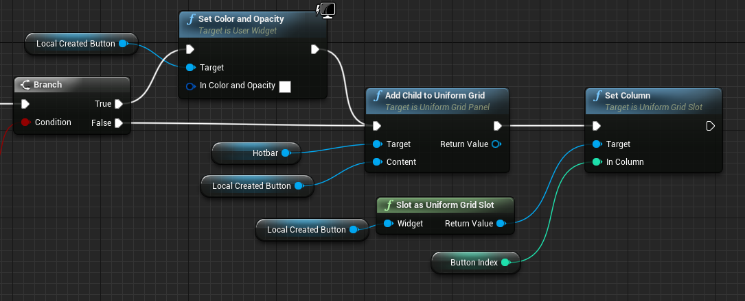
Event graph
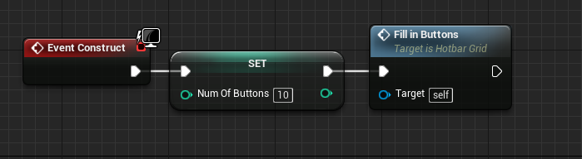

The child widget blueprint
An overlay with a border, image, and text on it
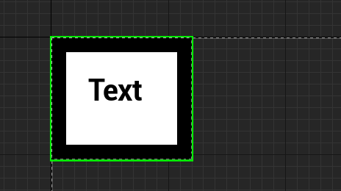
Variables
ThisText type text(used for binding the text widget
ThisImage type Texture(used for binding image widget)
There are no functions in the child widget blueprint(except for the bindings for the text and image)

Second Inventory (more complex)
Inventory Blueprint
Nothing in viewport
Variables
AmountOfSlots type integer (total number of items allowed in the inventory)
MaxStackSize type integer (max items allowed to be stacked in one slot)
Character type ThirdPersonCharacter (reference to player’s character)
Slots type InventorySlots array (this is the actual array for the inventory)
SlotsPerRow type integer (number of slots in each row)
MainWidget (reference to the main widget)
InventoryWidget (reference to the inventory widget)
Event graph
Begin play event
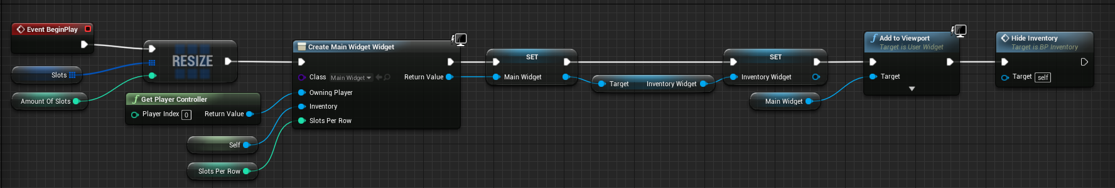
Update slot at index custom event
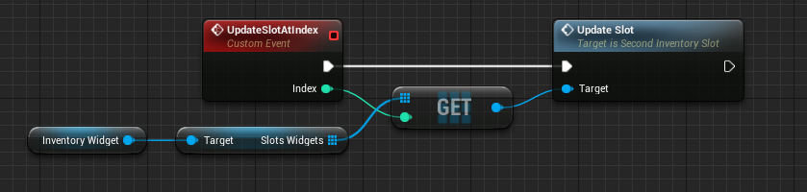
Use item at index custom event (right now this only removes one item from the inventory)
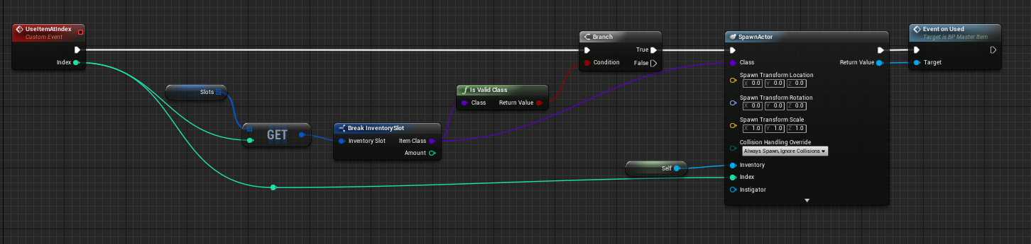
Hide inventory function
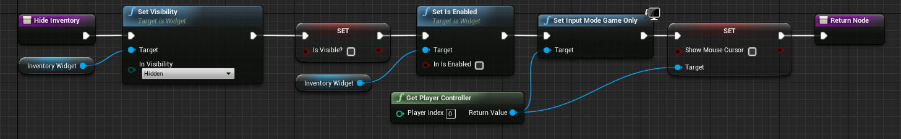
Show inventory function
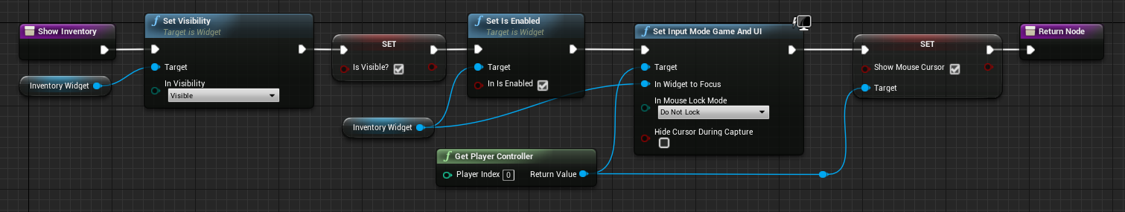
Get item info at index function
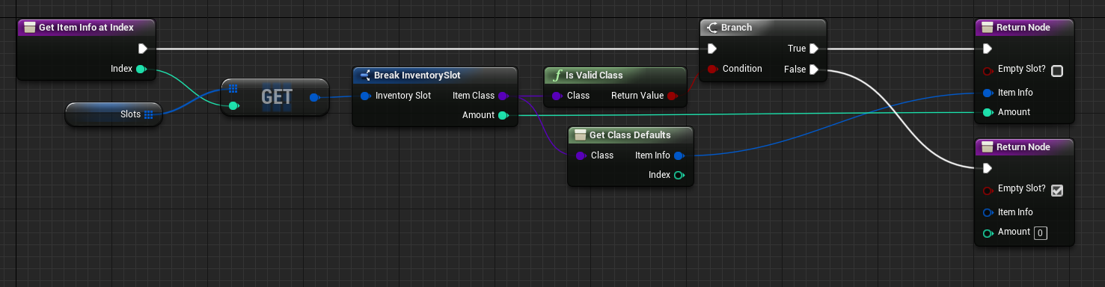
Search for empty slot function
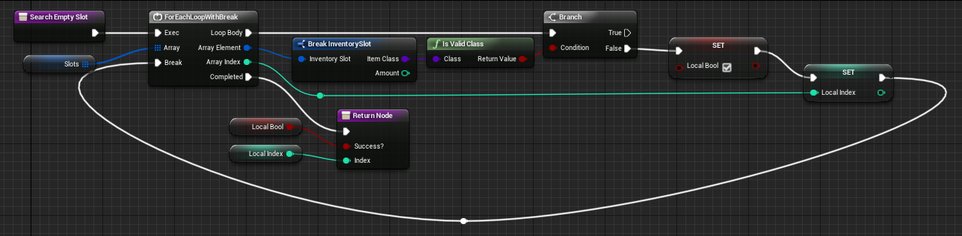
Get amount at index function
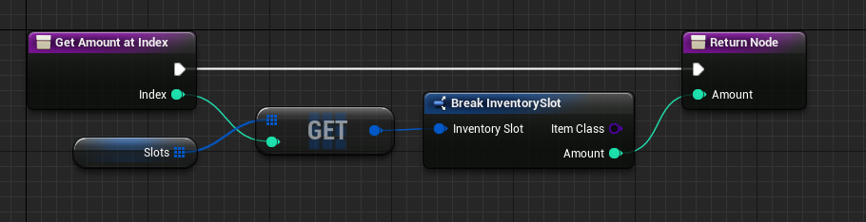

Remove item at index function (3 images)
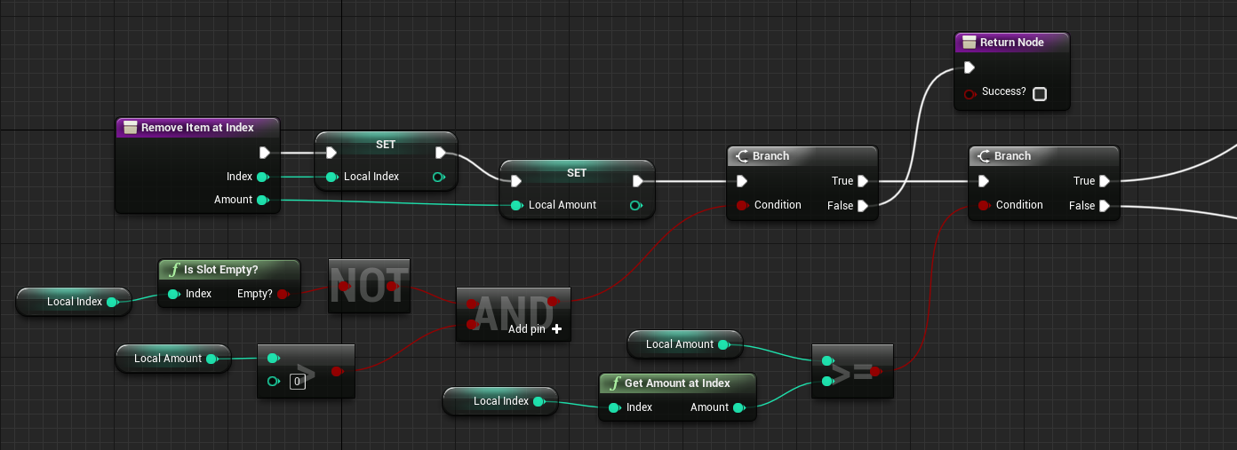
Branch is true
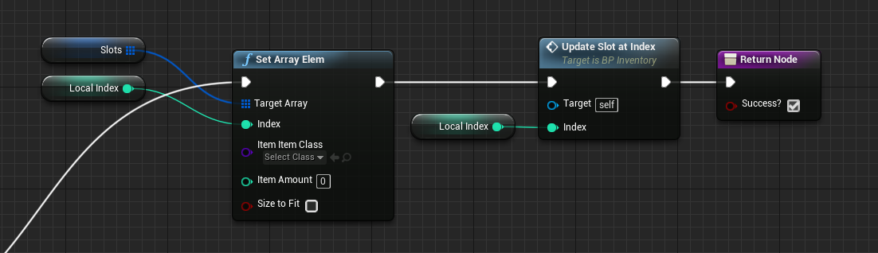
Branch is false
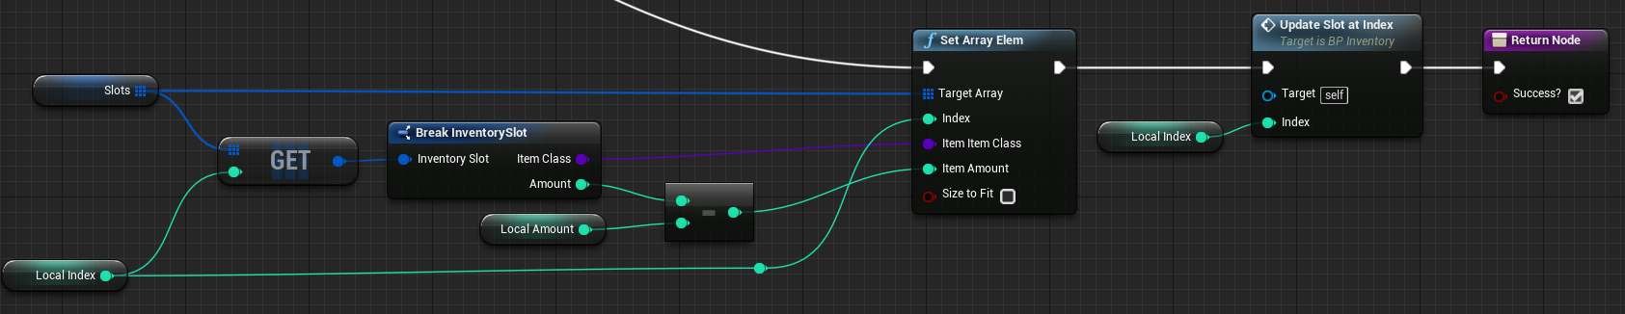Split stack function (2 images)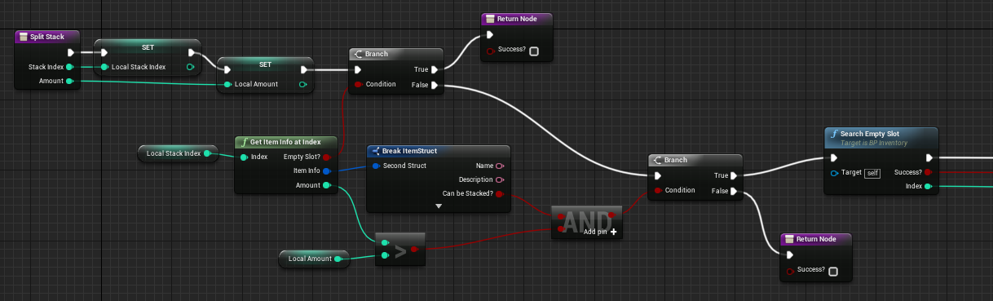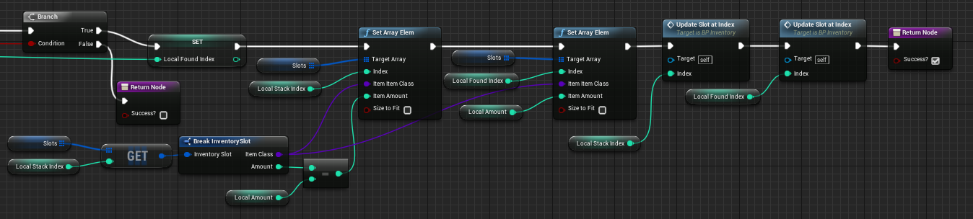
Swap slots function (2 images)
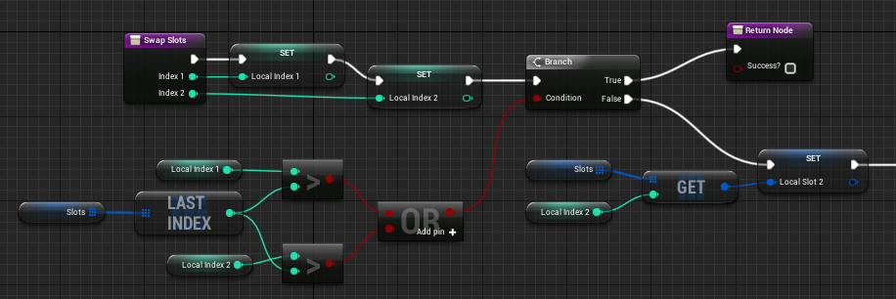
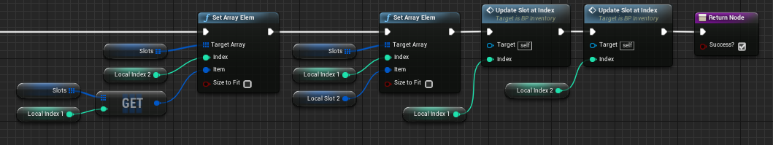
Add item function (8 images) (this one is a little confusing to follow)
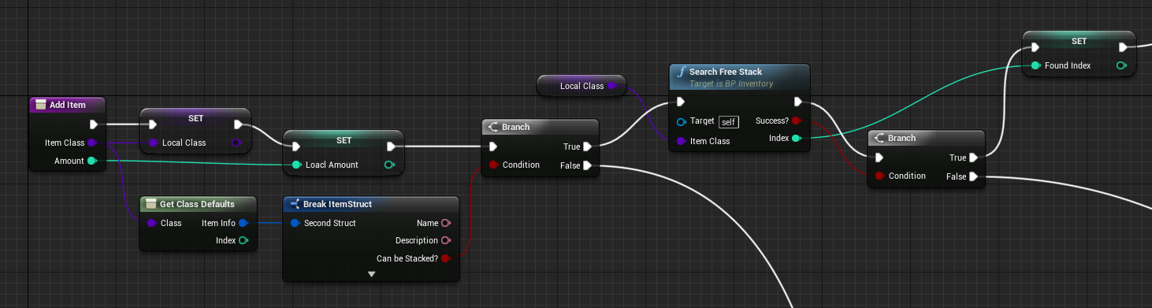
First branch is false (item is not stackable)
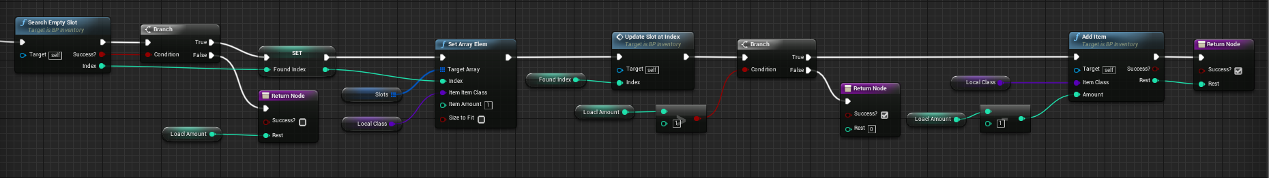
Second branch from the first image false (no free stacks were found)
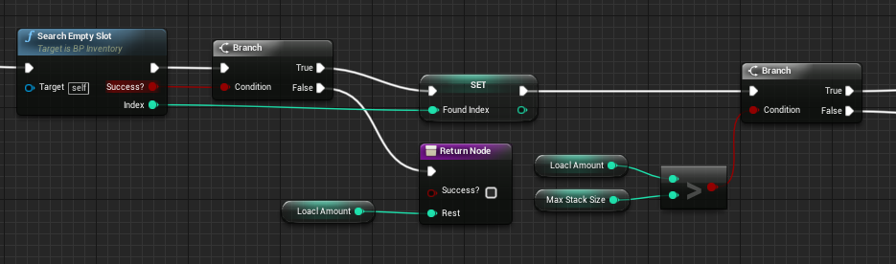

Branch is false (amount is less than max stack size)
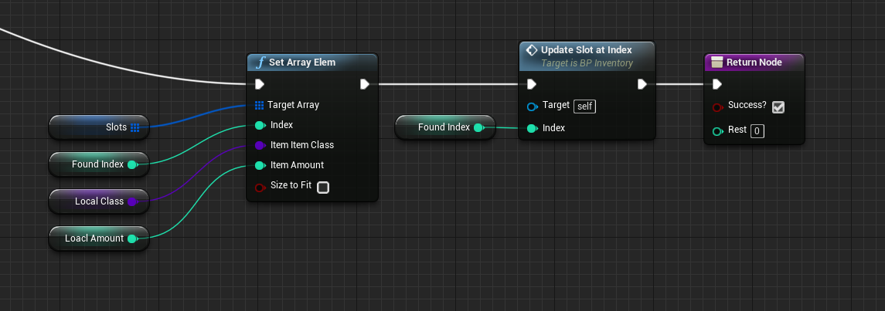
Branch is true (amount is greater than max stack size)
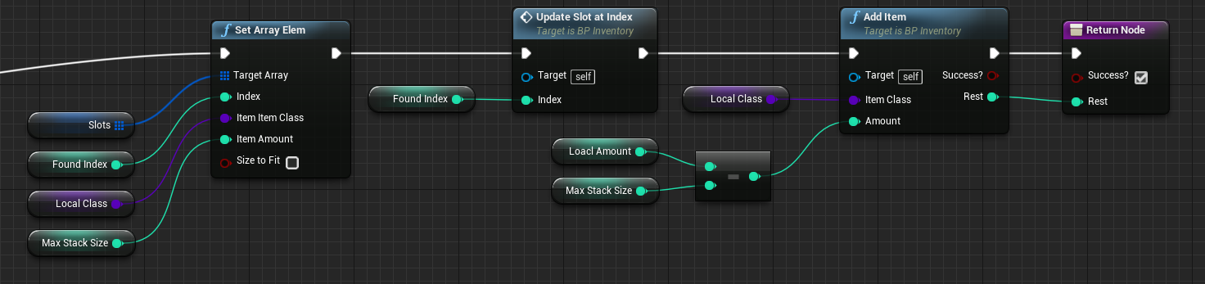
Second branch from the first image is true (a free stack was found)
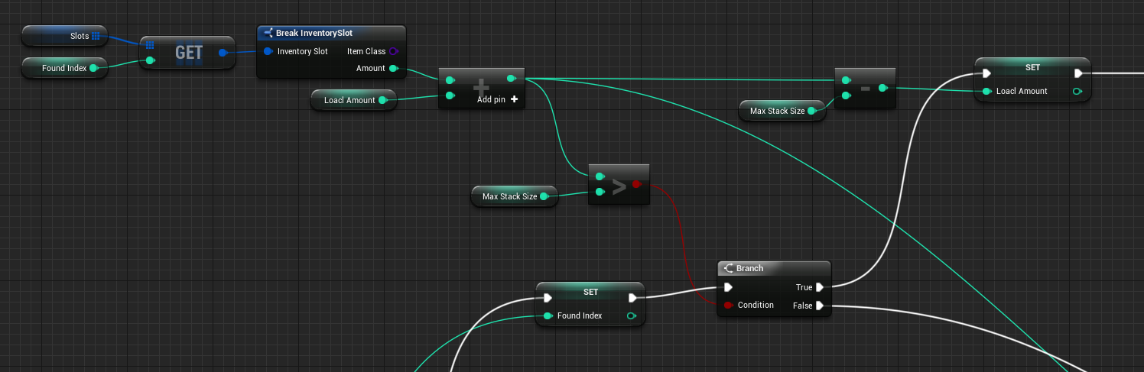
Branch is false (amount is less than max stack size)
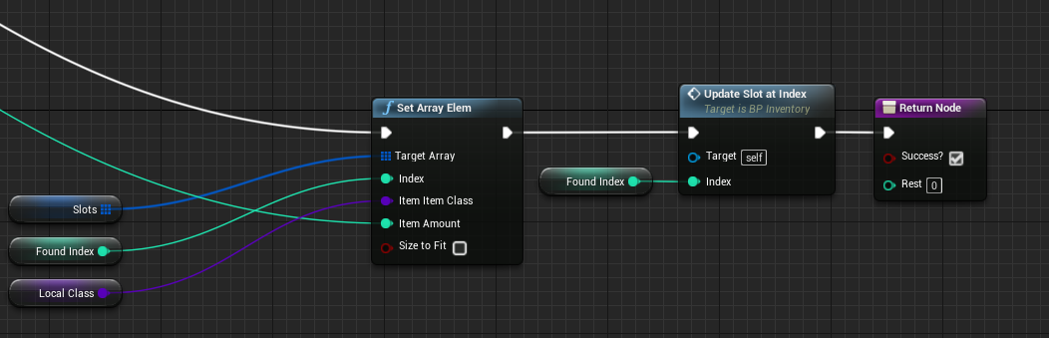
Branch is true (amount is greater than max stack size)
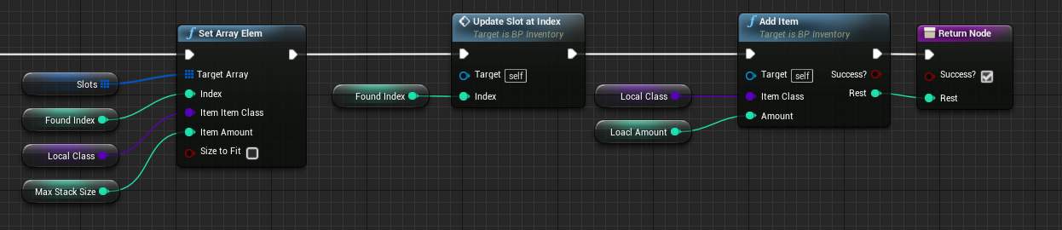
Item struct
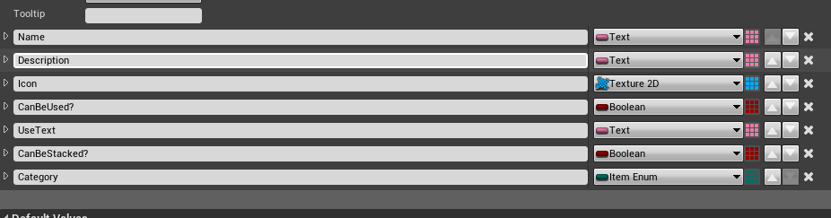
Inventory slot struct
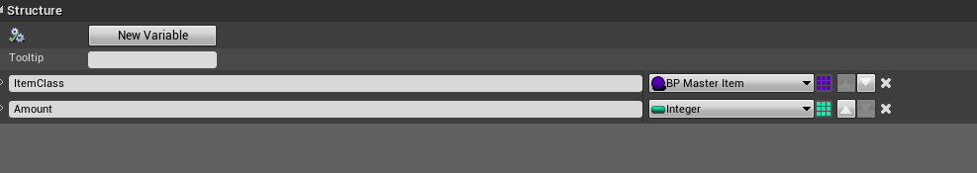
Inventory slot button blueprint
Just a button with an image and text
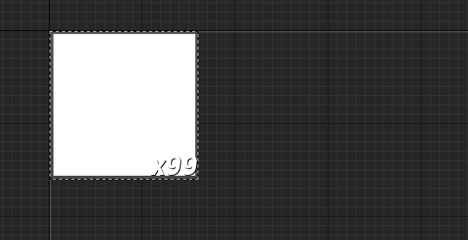
Update slot custom event
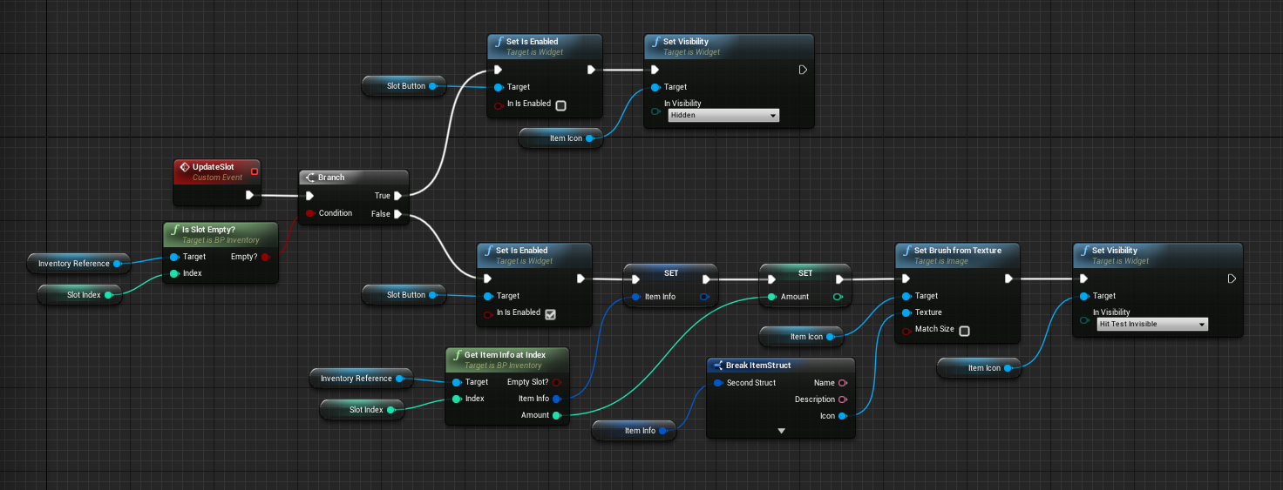
Overridden on mouse button down function
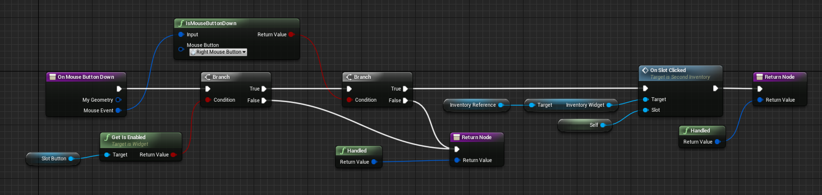
Text visibility binding
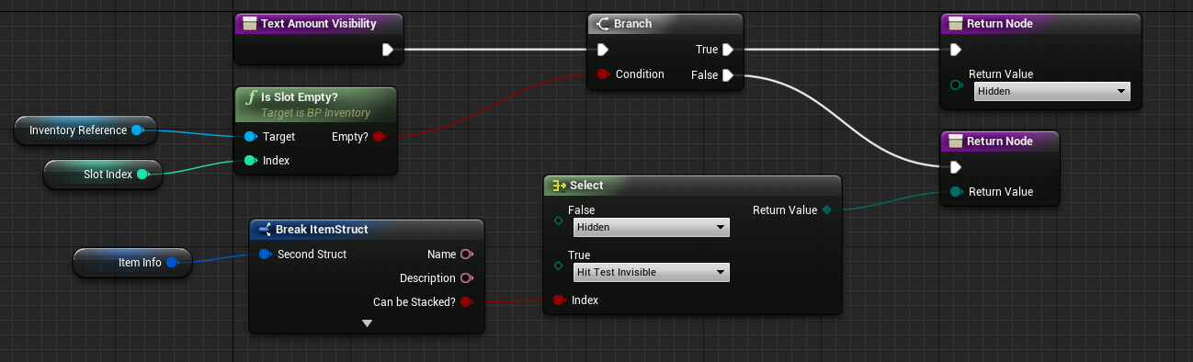
Second inventory widget blueprint
On slot clicked custom event
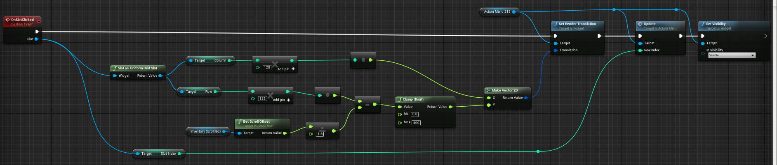
Generate slot widgets function
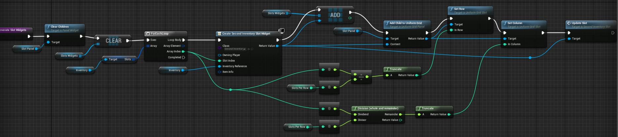
Overridden on drag detected function
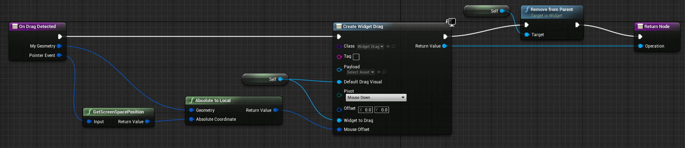
Overridden on mouse button down function
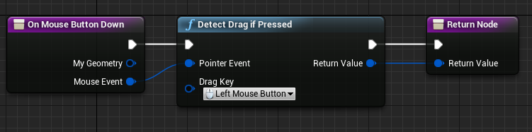
Main widget blueprint
Contains a second inventory widget
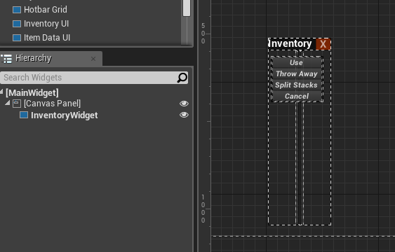
Construction event
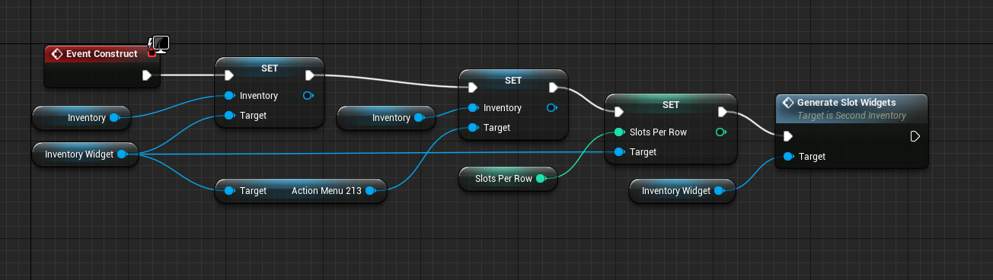
Overridden on drop function
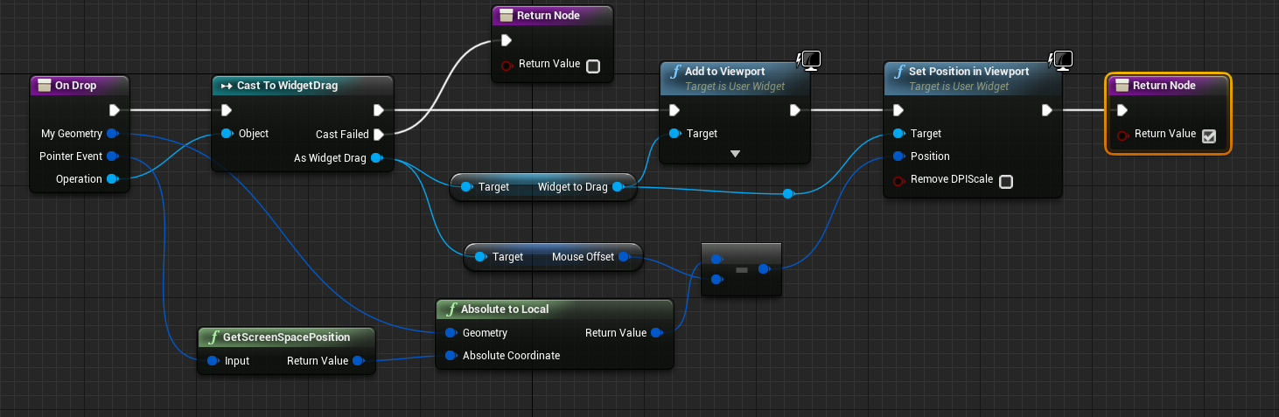
Action menu widget blueprint
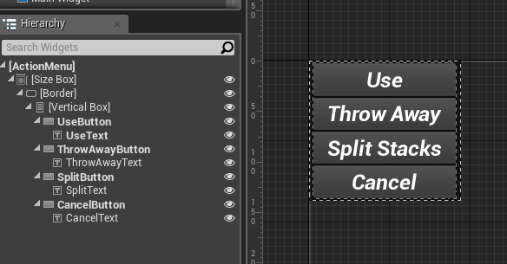
Use button clicked event
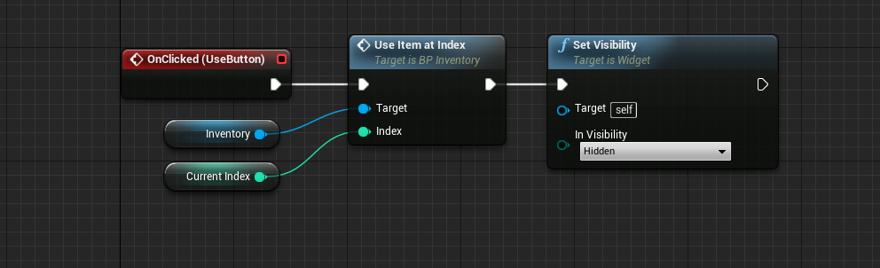
On cancel button clicked event
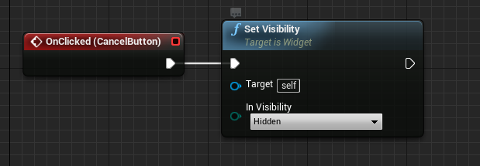
On split button clicked event
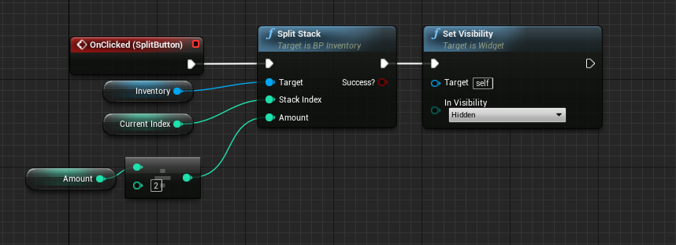
On throw away button clicked event
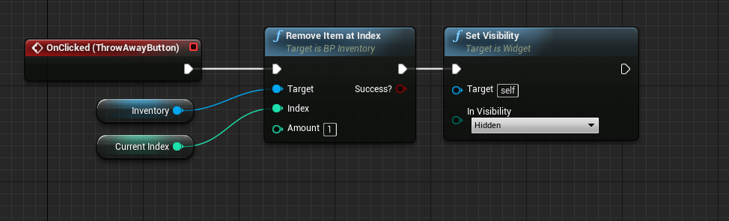

Tutorial Links

First Inventory (simple)
https://www.youtube.com/watch?v=gralQZmI7-Y

Hotbar
https://www.youtube.com/watch?v=e8MPDnVX1h4&t=284s

Second Inventory (more complex)
https://www.youtube.com/watch?v=seXX_iWM4Fw

I did make some slight modifications to the blueprints, so some of them won’t be exactly how the tutorials have them.

