Michael Lin
Unreal Engine 4
CSCI 340
Foliage and Grass Tools
Content used from Epic Games

The grass tool is part of the landscape paint which applies grass differently than if you were to use the foliage tool. First right click the content browser and under miscellaneous, click on the landscape grass type. Open the landscape grass type and insert your grass mesh.
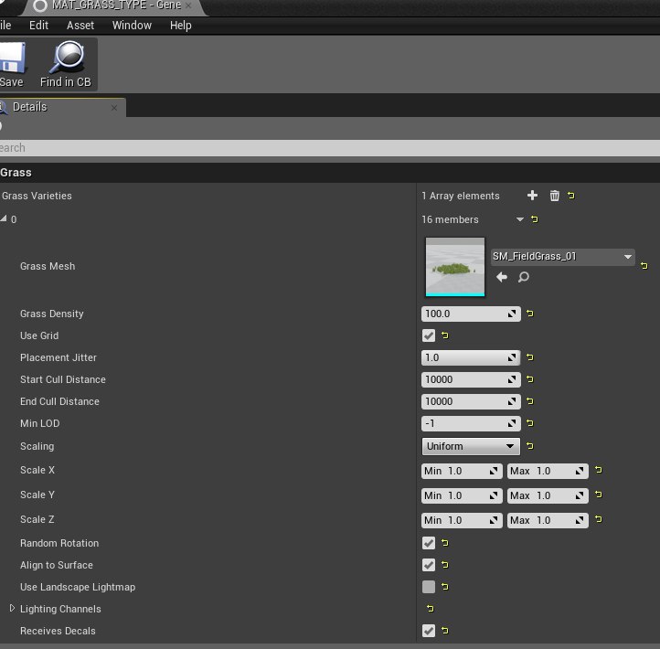
We can edit values in this menu such as:
Density for how many you want to spawn in a specific amount of area.
Scaling can be changed to make the static mesh stretch one way or another and make it taller or shorter.
Random rotation so the static mesh will be automatically rotated and look different, as well as many other things.

Exit the landscape grass type and right click your browser again and create a material.
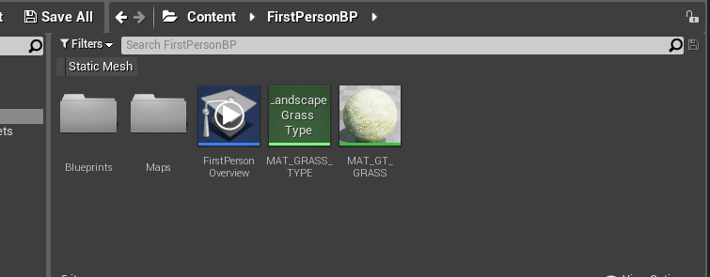

Edit that material. Grab a texture sample and use whatever you want the texture sample to be.
Grab a landscape layer blend, landscape layer sample, and landscape grass output from the palette.
Connect your texture sample to the layer blend and connect the layer blend to the material. Make sure to name the layer appropriately.
Edit your landscape grass output and insert your landscape grass type you made before and name it.
Go to your landscape layer sample and name the parameter the name of the layer blend you wish the grass (static mesh) to attach to. Then connect it to the landscape grass output.
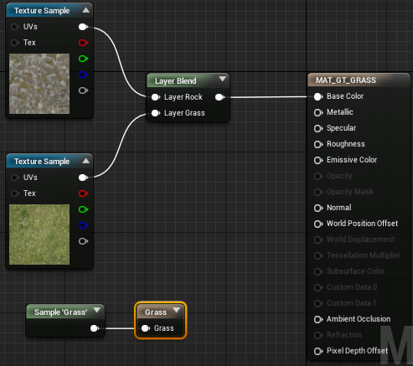
Save the material, and you’ll be done.

Create a landscape using the landscape tool.
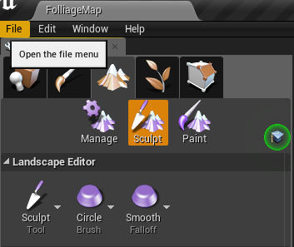
select it, and insert the material you just made into the landscape material.
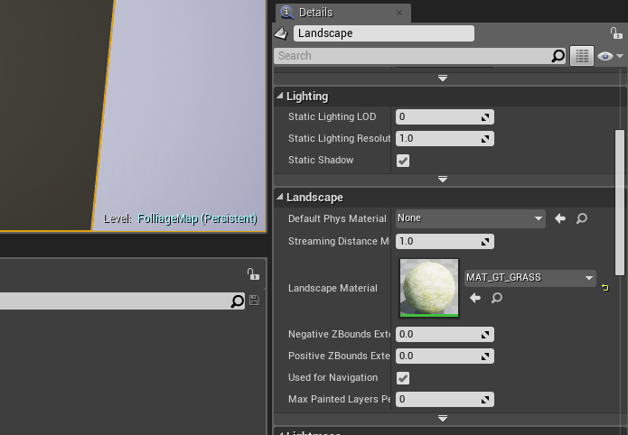
Go to the paint mode of the landscape, add the layer info and paint away.
The foliage tool which is to the right of the landscape tool is very similar to the paint tool of the landscape tool.
Simply drag and drop static meshes to the box underneath the search foliage bar. When clicking on the static meshes you have placed, you can edit how they are placed and many other values in the box under the static mesh boxes. Adjust your brush size and paint density and place and undo foliage until it’s at a comfortable value for you to use. Erase density is a bit finicky, if there is a place you want to lower or just delete the amount of foliage there, the Amount of erase density is the amount of foliage that will be left behind after the delete, 0 means all foliage will be deleted in the clicked area. Shift click to use the erase density tool.
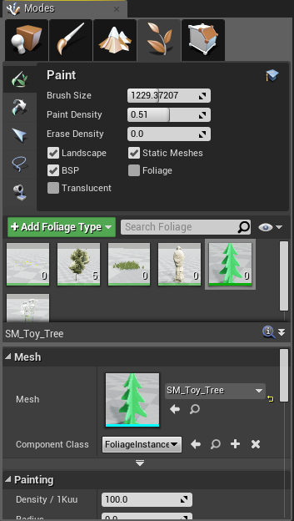
A Quick Look at the Swarm Agent

When building your level, you will see Unreal open something in your task bar called the Swarm Agent. Swarm Agent is a program within Unreal Engine that works with Lightmass to pre-compute lighting for levels.
When opening it up, you will be brought to this screen.
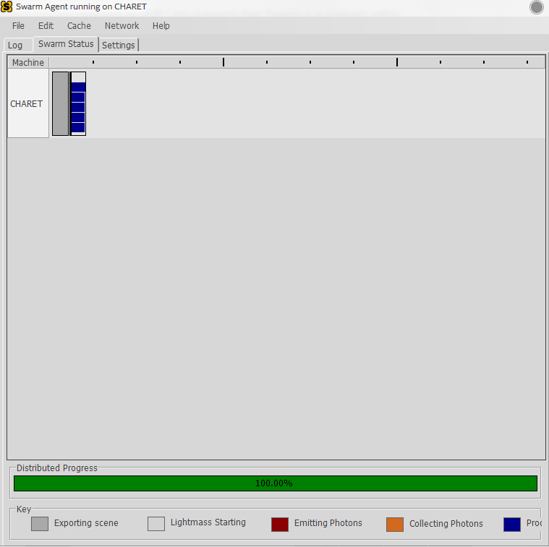
If you are building a large amount of lighting, your Editor in Unreal will probably be stuck at 0%(Pre-computing) for a little, but in the Swarm Agent, it is much more detailed to track what stage of building it is currently on.
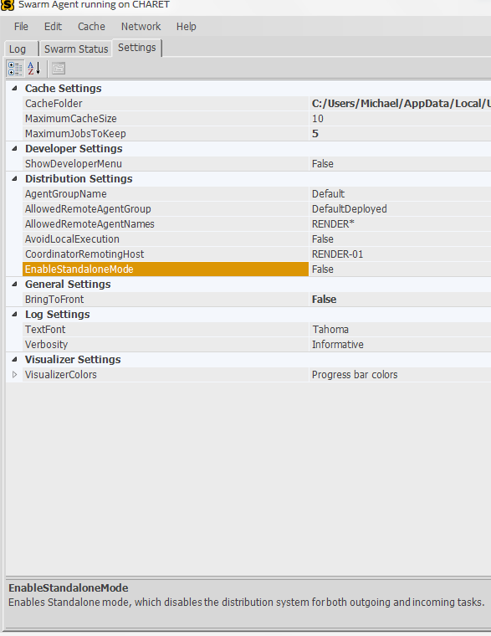
Swarm Agent has another program called the Swarm Coordinator which connects computers on a network to build lighting together to improve the overall time it takes to complete to build lighting.
I don’t exactly know what everything does in the settings but from what I’ve read, setting EnableStandaloneMode to true if using a single computer, will improve your build time by some.
If you have any questions, feel free to contact me!

Tutorial referenced:
https://docs.unrealengine.com/latest/INT/Engine/OpenWorldTools/Grass/QuickStart/index.html

