Larry McFarlane
Day night screen shots notes
Note this is an actor blueprint
To set a day in mins
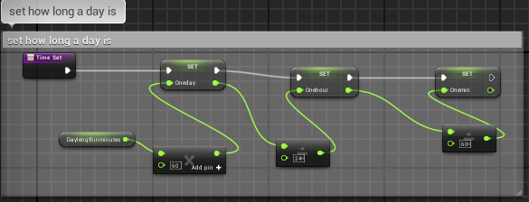
Time tick update sun
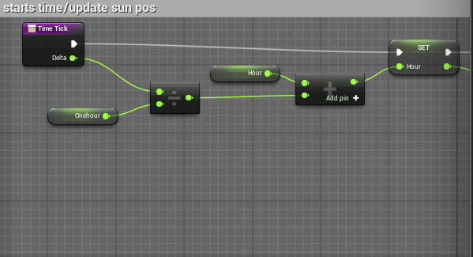
cont
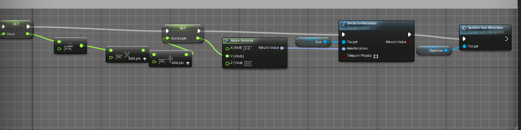
Variables needed note sun is the light source and skydome is bp_sky sphere also both must be set to moveable
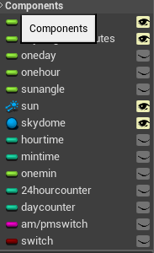
Am/pm function 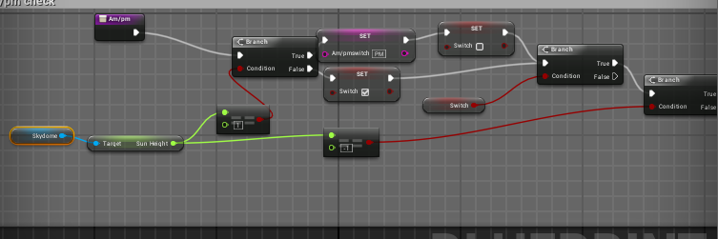
cont
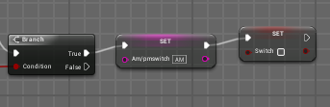

Example of time based event
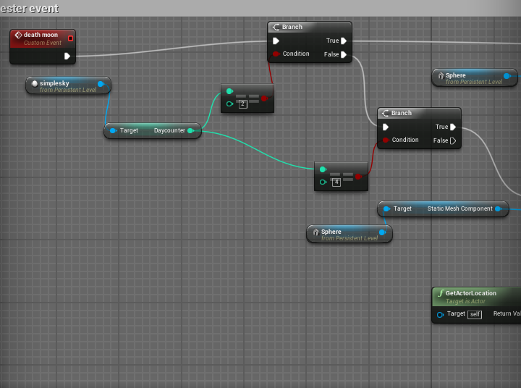
Cont
