Zachary Gransubry
CSCI 340

Investigation – Animation Blueprint/State Machines

In order to make an animation state machine you right click in content browser go to animation, than animation blueprint. This will bring up the following dialog box.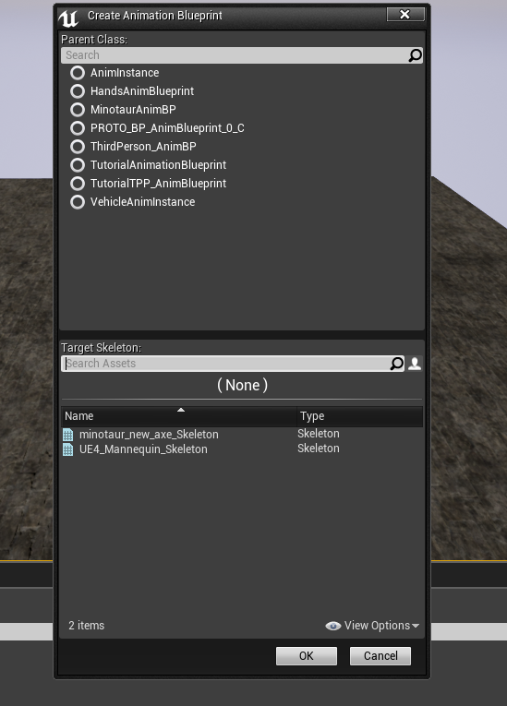
Make sure you select the correct skeleton that you want to make the animation blueprint for as well as parent class. I used the AnimInstance.

Doing so will bring up a window like the one below:
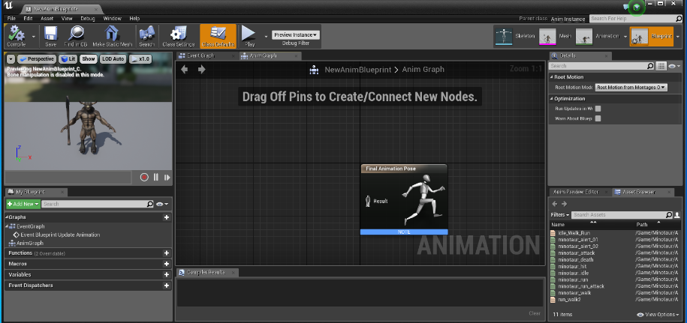

At this point you go in right click and add a New State Machine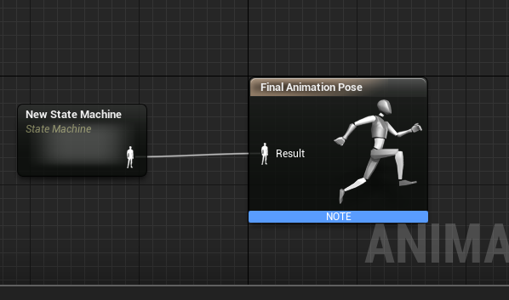

Click on the state machine then you can go in and start building the state machine

Here is the animation state machine that I am currently using:

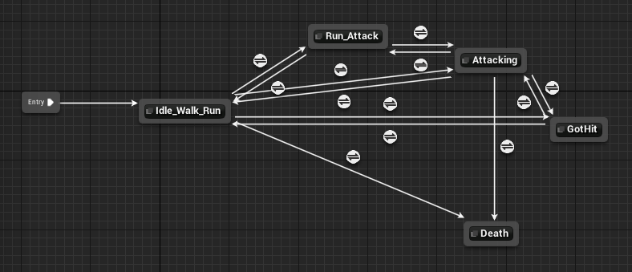
Need to make sure that the states are able to traverse back and forth so that one does not get stuck within a state. That is, except the death animation for obvious reasons.

In each of the states you connect what animation should be playing to the Final Animation Pose. This can be done by dragging the animation you want from the asset Browser.

The conduits are where the code comes in, they decide if one can move from one state to another.
The code to get from running to running/attacking is simple:

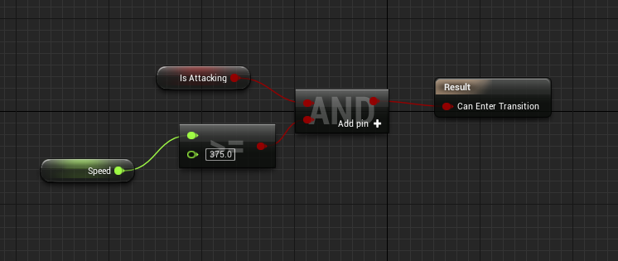

BlendSpaces – Blend spaces are used when you have a specific range in which you want to blend two (or more) animations. As in going from idling to walking to running over a set speed In order to create a blendspace it is much the same as with creating the animation blueprint. Right click go to animation then click blendspace 1D. 1D is obviously for one dimensional blendspaces, as in only one variable will affect the blendspace. I did not fiddle with the other blendspace while making this. This will pop up a pop, pick the correct mesh you are using in which will bring you to:

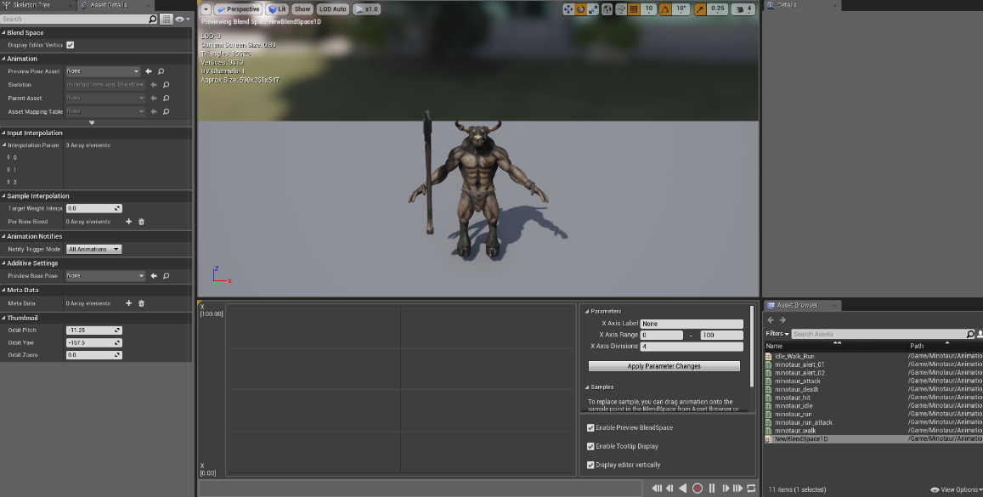

From here you drag idle to the bottom, walk higher up then run to the highest, and make the range go from 0-375. You can now use these blendspaces in the animation state machine.

In order to get the animation state machine to work I had to have variables that my character would set by casting to animation blueprint, like so:
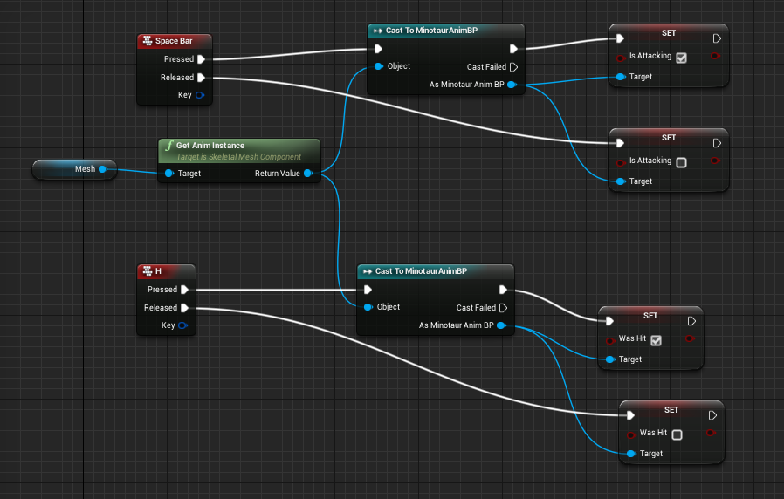

The source I used for some of this was - https://www.youtube.com/watch?v=7b9WM8TVdpA, it is a tutorial for making a complete game this is video seven which starts the blendspace. From video 8 on is the state machine and animation events

