Disclaimer: If this documentation is bad, or you’d rather watch the videos, just watch this playlist https://www.youtube.com/watch?v=OXK2Xbd7D9w&index=1&list=PLZlv_N0_O1gYDLyB3LVfjYIcbBe8NqR8t
Particles
- Particle- Point in space with behaviors.
- Particle System- Like a flipbook, but for particles
- Emitter Actor- Holds reference to Particle System
- Particle System Component –
- Cascade- Particle editing system in unreal
  - Copy and share module- modules that share properties
- Standard sprite emitter- generates a bunch of sprites
- GPU Sprite emitter- Sprites Calculated on GPU
- Mesh Emitter- Spawns static meshes
- Beam Emitter- creates a particle effect between two points, with adjustable tangent
- Ribbon- Ribbons that can follow other particles
- AnimTrail Emitter- Movement particles. Things like blur on a moving character

Sprite Emitter
- Create a new material
- Select your material, set blend mode to translucent, and set shading model to unlit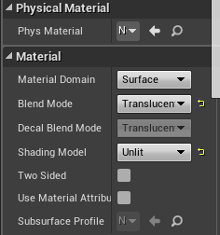
- Create a particle node, a Radial Gradient Exponential node, and a couple of multiply nodes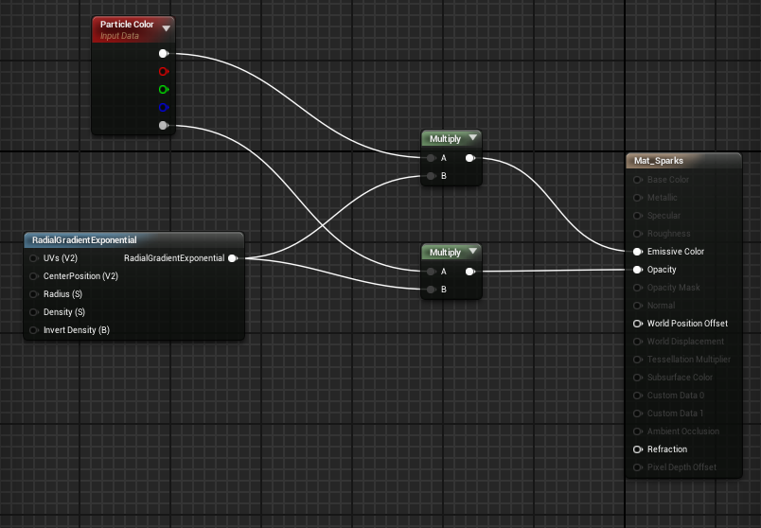
- Select the Required Module and set the material you made into the material used for the emitter
- 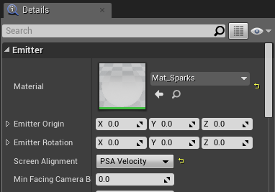
- Set Screen Alignment to PSA Velocity
- Select your initial size min and max to create varied sizes in the particles that spawn

- Create an initial Location module by right clicking under the modules, highlighting Location, and selecting Initial Location
  - Set the min and max values to spread out the particle spawn points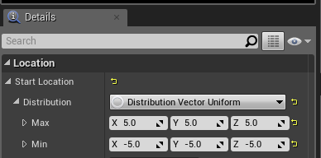
- Create an Initial Velocity module which can be found under Velocity
  - Set the min and max values to get variation in in particle speeds
  - You will have to expand the distribution drop down to find many module values
- You can edit the min and max values of the Lifetime module to alter the time the particles exist
- Create a Const Acceleration module under Acceleration and set the Z value to -980 to give it the appearance of having gravity
- Select Color Over Life to change the color the initial color of particles and what color they transition to through their lifetime
- 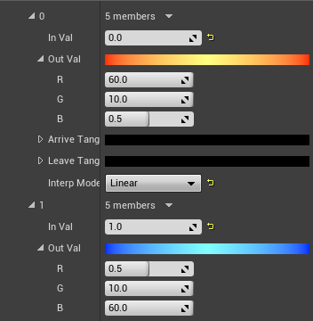
  - The color values go from 0 to 1, but if you put the values above 1, you start to get a neato glowing effect
- You can give a subtle stretch effect by creating a Size by Speed module, which you can find under Speed, and fiddling with its values
- Create an Actor Collision module from under Collision
  - Bump up the min and max collisions
  - Increase the damping values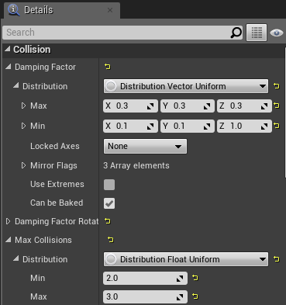
  - This makes particles collide and bounce off of meshes

GPU Emitter
- Duplicate an existing sprite emitter and open its cascade
- Right click the area above the required module (part I outlined in yellow in picture below)
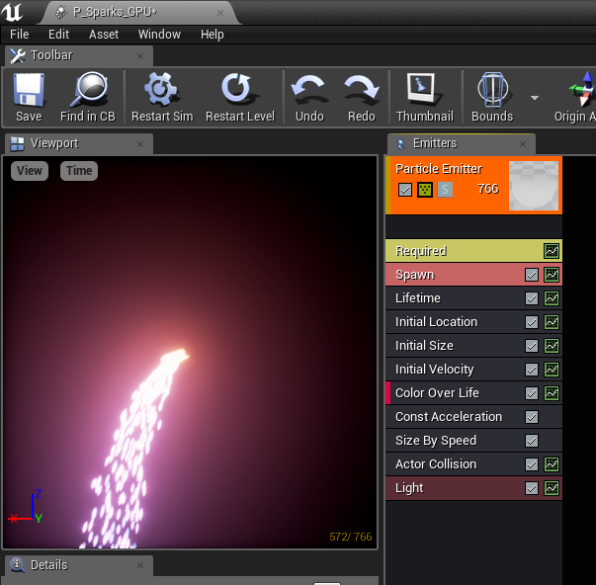
- Select “Type Data” then “New GPU Sprite”
- Delete the new actor collision and light modules
- Bump the particle spawn rate WAY up (I put mine to 2000)
- If you want the particles to stay a constant color, set the distribution to a vector constant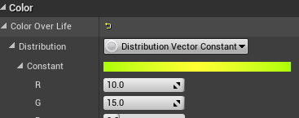
- Click Bounds dropdown arrow, then Set Bounds to keep particle effects from disappearing in your peripheral.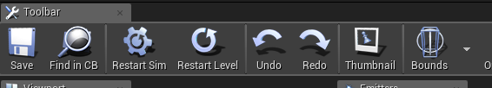
  - If you want to alter the properties of your bounds, click the empty space to the right of the modules, then scroll through the details tab to the bottom left for Bounds
- Create a Collision (Scene Depth) module and set the resilience to alter the bounce of the particles (Or don’t if like bouncy particles)
- Vector Fields: They influence the movement of particles
  - Add a local vector module to the particle effect
    - Select Vector Field, then Local Vector
  - Select which vector field you want (Content examples comes with some, I used vel_219) 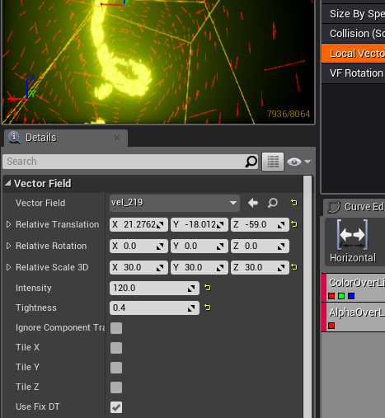

- To show your vector field, do these:
  - 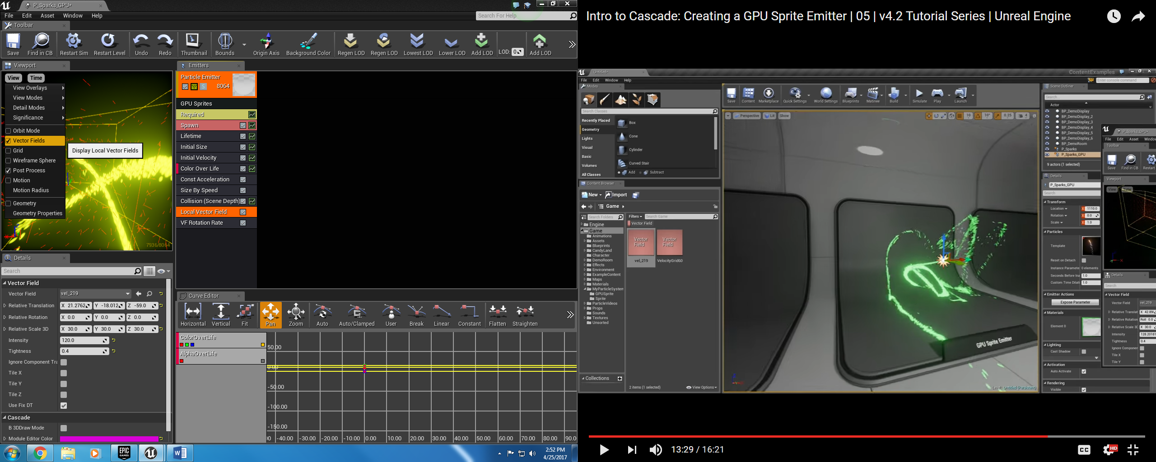
- Then you can edit stuff
  - Relative translation moves the vector field
    - Rotation and scale also do what you think they do
- Intensity alters the force of which the vectors push the particles
- Tightness alters how much the vectors influence the direction of the particles (From 0 to 1)
- Add a vector field rotation rate to make the particle paths more dynamic
  - Right click near the modules, highlight Vector Field, then click VF Rotation Rate
  - Then change the rotation rates of each coordinate. (I recommend values around 1)

Mesh Emitter
******* Optional Color Change Stuff *****
- Delete the Base Color node of a Material and replace it with a Particle Color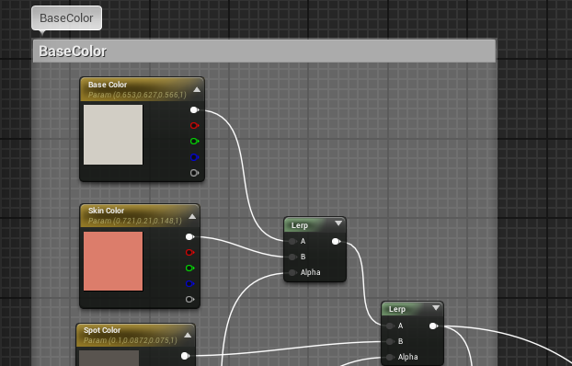
- Multiplying the particle color by any other colors is a good way to make it look nicer (ex: The spots of a toy cow)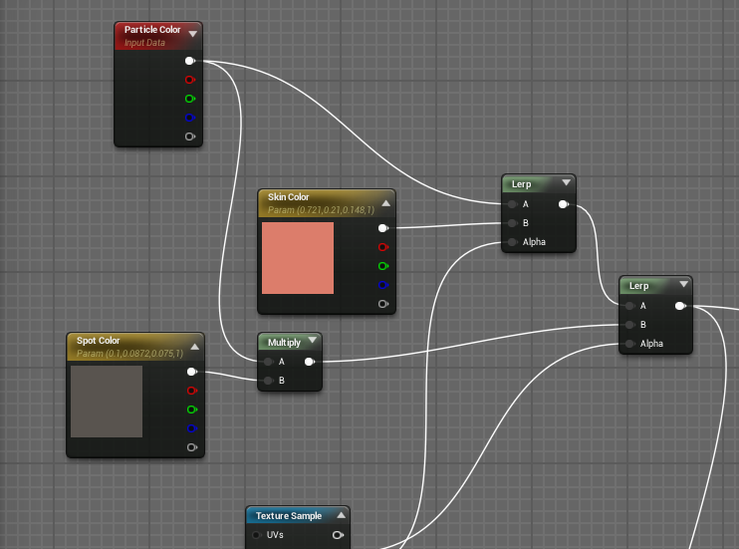
******** Real Stuff **********
- Open Cascade of a new sprite
- Right click above the Required Module, highlight Type Data, then click new Mesh Data
- Click the Mesh Data module, then set the mesh it emits in the details tab to the bottom left
- You may also want to change the initial size and lock the xyz axes to keep the object from being squashed/stretched
- Add an initial color module if you did the bonus color thing
- To create a spawn area, right click under the modules, highlight location, and select what shape you want (I made a sphere)
  - Check the 3D draw mode box to see spawn area size
  - Mess with the size attributes to spread out or constrain the spawn area
- To make them spawn in at random rotations, right click under the modules, highlight rotation, then click init mesh rotation
- To keep the meshes from falling through the floor, add an actor collision module which can be found under collision
- Increase max collisions and damping to create a bounce effect
  - You also might want to increase the lifetime
Beam Emitters
- Create a new material
- Change the blend mode to Translucent
- 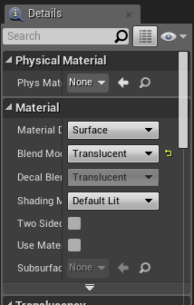
- Create:
  - A texture coordinate
  - Component Mask (Uncheck the R box)
  - A multiply (Change const B value to .5)
  - A sine
  - A power (Change the const exponent value to 3)
- Make a Particle Color and multiply it by the chain created above and plug the result into emissive color
  - Multiply the bottom pin by the chain and plug it into opacity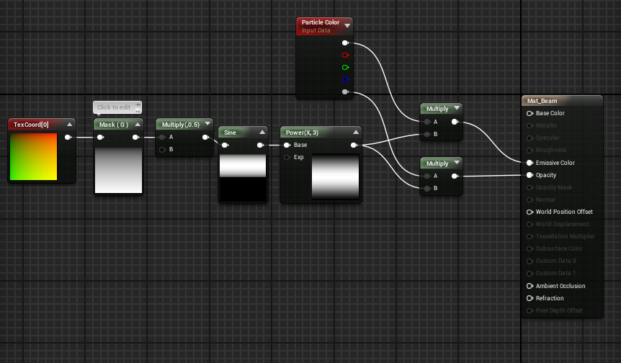
- Create a new Particle system
- Set the Type data to beam (Same way you set the gpu or mesh type data)
- Drag the material you just made into the material for the emitter (click the required module if you can’t find it)
- Create source and target modules which are both found under beam
- Set the coordinates of the source to x: -200 y: 0 z:0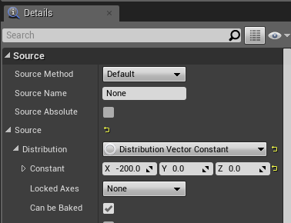
- Set the coordinates of the target to x: 200 y: 0 z:0
- Set the speed to 0 in the required module to make the travel time from source to target instant
- Change the spawn rate to 1
- Change the initial size to whatever you’re feeling like
- Remove the color Over Life and replace it with an Initial Color Module
- Change the initial color to whatever best describes your personality
- Tangent Time
  - Select the Beam Data module and add more interpolation points in the details tab to give your tangent a rounder arc
  - Select the Source module, set the Source Tangent Method to User Set, and set the coordinates to x:0 y:0 z:40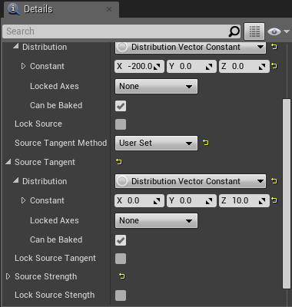
  - Do the same for the Target module, but set z to -40
- Create a Noise (Right click then highlight beam)
- Set the Frequency of the Noise module to 10 and enable Low Freq
- Set the Noise range to Uniform and the mins of the y z to 20 and their max to -20 (Or just do you)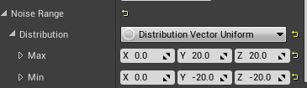
- Select the Beam Data module and increase the Max Beam Count to something like 3
- Then go back to the Spawn module and Bump the spawn rate back up to something like 25
- Now you should have some cool lightning
- To Dynamically set what the particle effect arcs between, you set the Source Method to User set and the distribution of the source Particle Parameter so that you can change the source through blueprints (Like with our battery pickup)

