In-game Building System
Tutorial used: https://www.youtube.com/watch?v=oSpl_qKToM8
In-depth tutorial (Recommend this guy after looking through his content. He has a TON of tutorials): https://www.youtube.com/watch?v=obHnnGOkaNc

FUNCTION AND EVENT GRAPH BLUEPRINT CODE INCLUDED (Copy all text from each .txt file and paste it into the blueprint of the respective function or event graph)

- Create an enumerated blueprint, I named mine “BuildingType.” This enum will represent all actors that you want to be place able within your game.
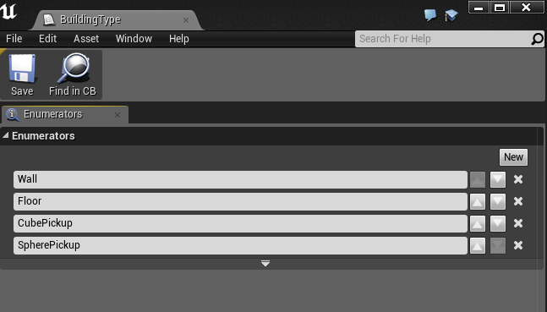

- Now within your character blueprint, you want to setup a variety of variables.
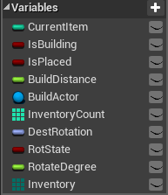
- CurrentItem (int) – the current object the player has selected in building mode.
Default = 0
- IsBuilding (bool) – Toggles building mode on and off.
Default = false
- IsPlaced (bool) – Set to true after an object is placed.
Default = false
- BuildDistance (float) – The distance the object will be displayed and placed in front of the player.
Default = 500 (comfortable in front of the player in First Person View)
- BuildActor (actor) – Reference to the object being placed
Default = none
- Inventory (“BuildingType” array) – An array of the enumerated type declared in step 1.
Default = (enum #1, enum #2, …, enum n)
- InventoryCount (int array) – Array to keep track of the count of each object at each index.
Default = (0,0,…,0)
- DestRotation (rotator) – Desired rotation for the Rotate function.
Default = (0, 0, 0)
- RotState (bool) – Changes the Rotate function between 90* and -90* rotations.
Default = false
- RotateDegree (float) – Desired rotation degree for the Rotate function.
Default = 90

- Now within your character blueprint you want to create a new function, “BuildingTrace.” This function is responsible for tracing the object from the player.

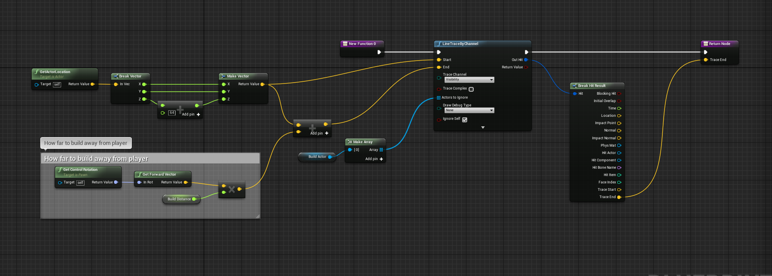

- Make another function, “NextItem.” This function is responsible for changing the current inventory index and selecting the next available building object. If the current object is above the index or the current object is not available it selects the next available item.
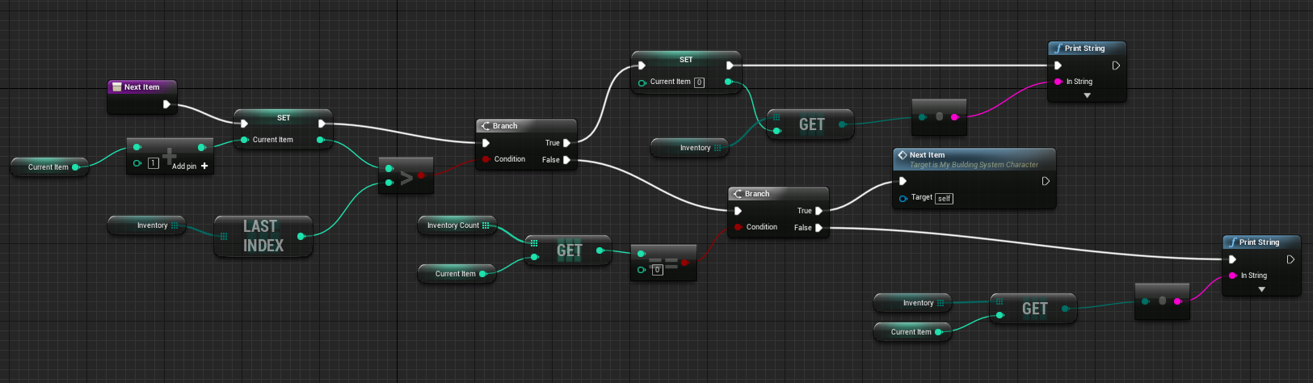

- Create a function, “UpdateInventory.” This updates a given inventory index by a given value. If the index is out of range, or the updated inventory count index is less than 0, do nothing.
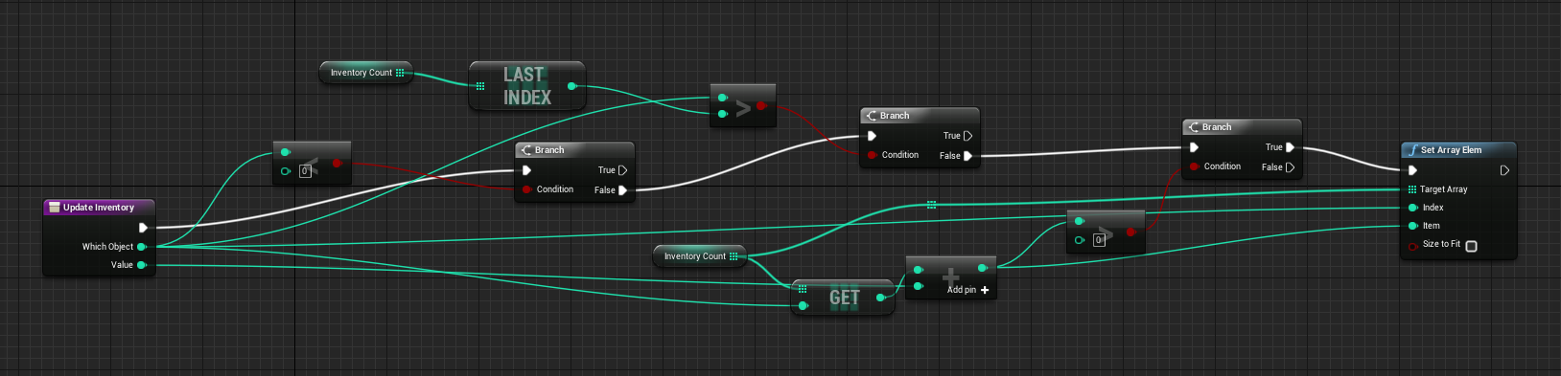

- Go into the Project Settings and under ‘Input’ create new Action Mapping Bindings. We need to create at least four binds.
- ToggleBuildMode
- NextObject
- PlaceObject
- Rotate
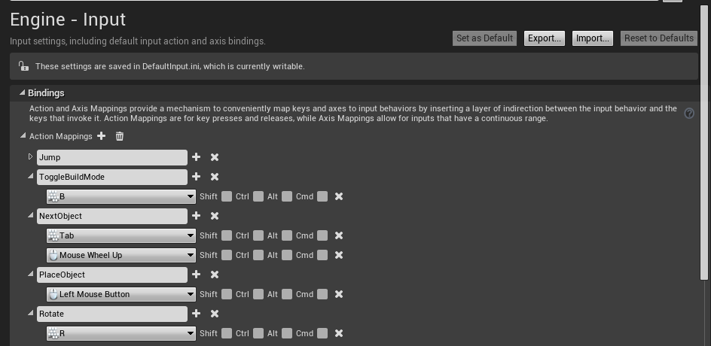

- The last steps are all within the character’s blueprint. Place an InputAction node on the blueprint that corresponds to your “ToggleBuildMode” mapping from step 6. This will allow the player to toggle building on and off.
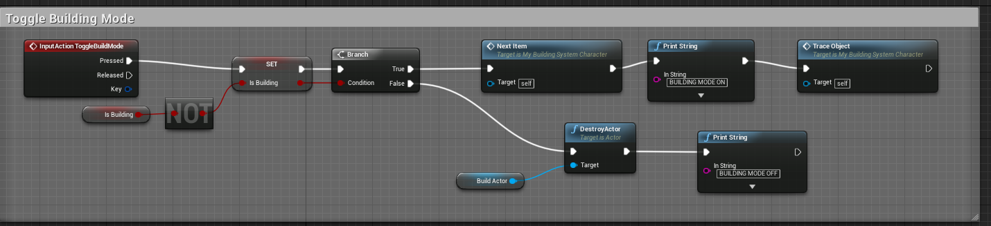

- Create another InputAction node that corresponds to your “PlaceObject” mapping. This event places the current selected object in the world and also updates the inventory count. It iterates to the next item if the current item is 0.
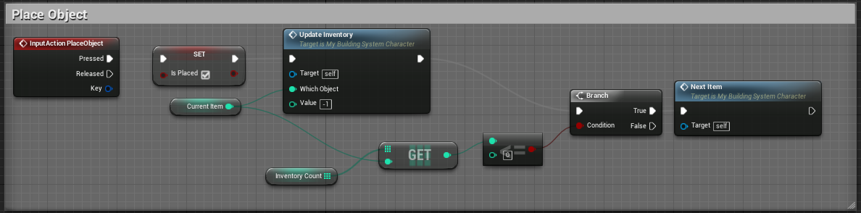

- Create another InputAction node that corresponds to your “NextObject” mapping. This event changes from the current build object to the next available object with a count > 0.
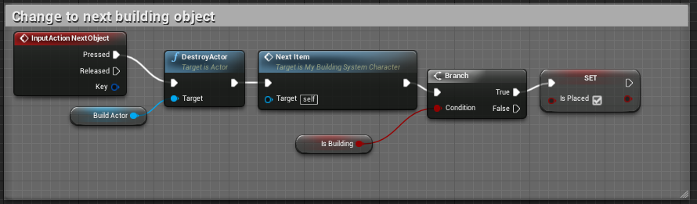

- Create another InputAction node that corresponds to your “Rotate” mapping. This event rotates the object 90 or -90 degrees on the Z axis.
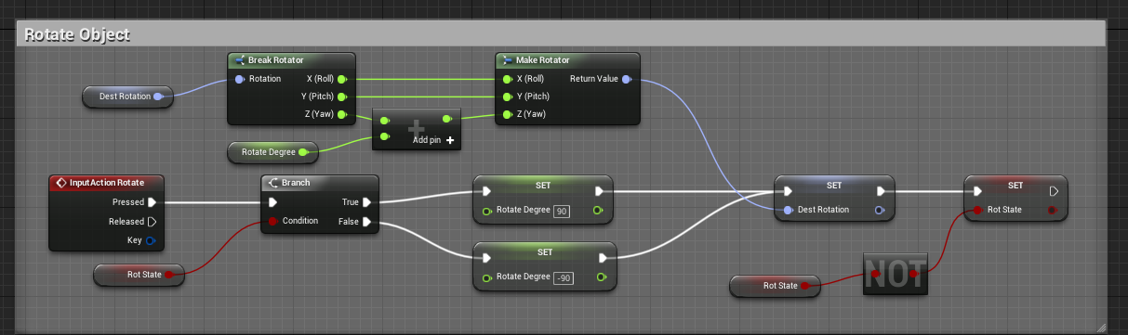

- Finally, create a custom event “TraceObject.” This event displays the current object selected. Make sure to fill the select statement in with each corresponding actor.
