Artificial Intelligence in Unreal Engine 4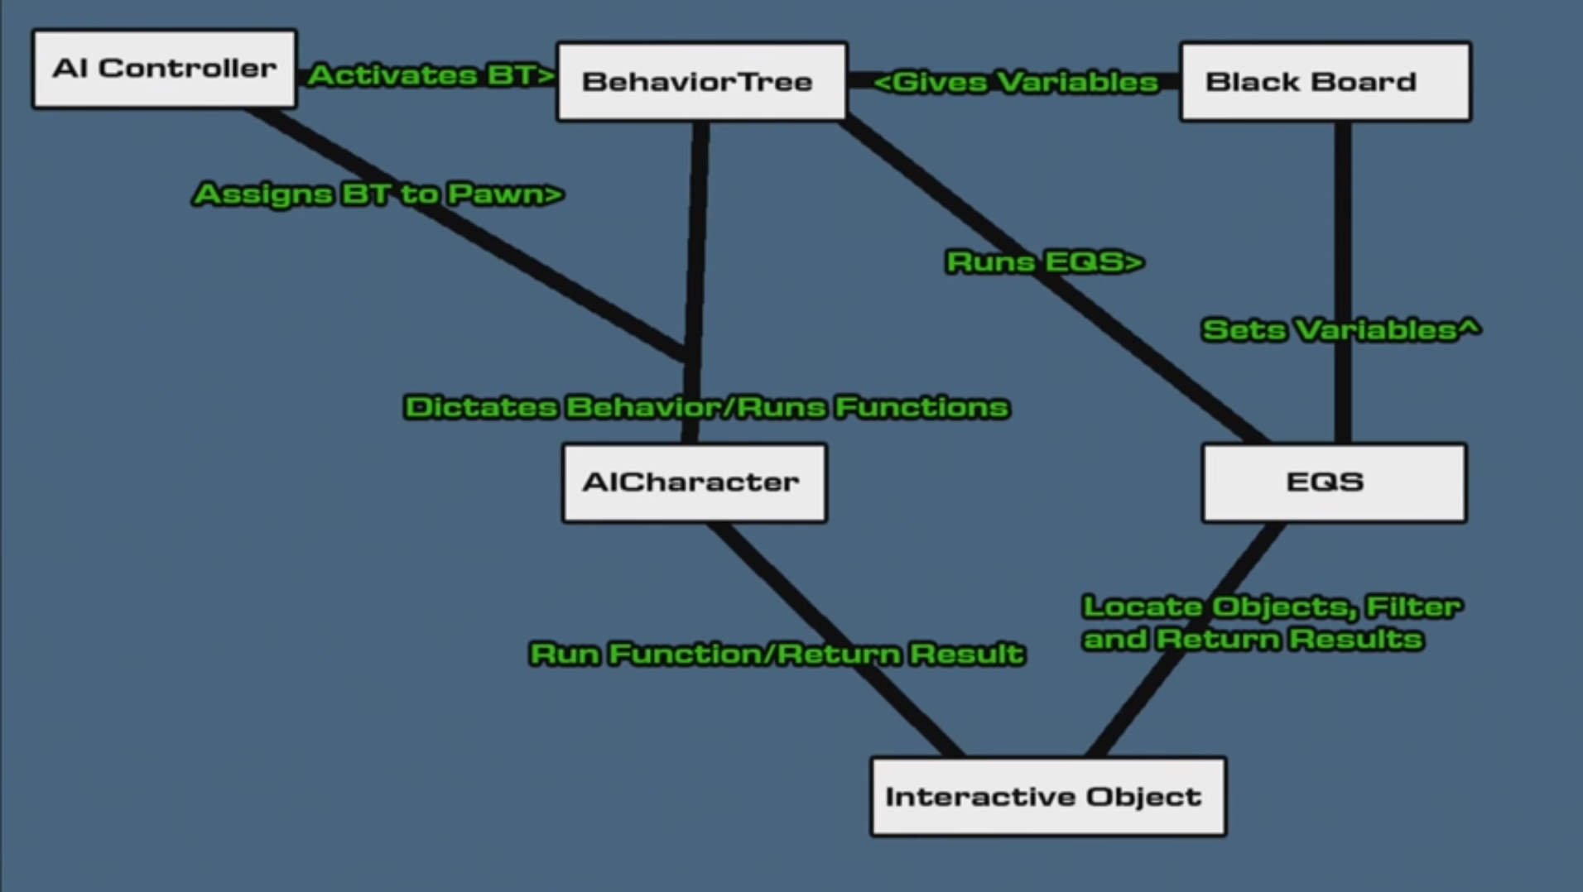

- Nav Mesh
  - Volume that divides the covered area into chunks for navigation.
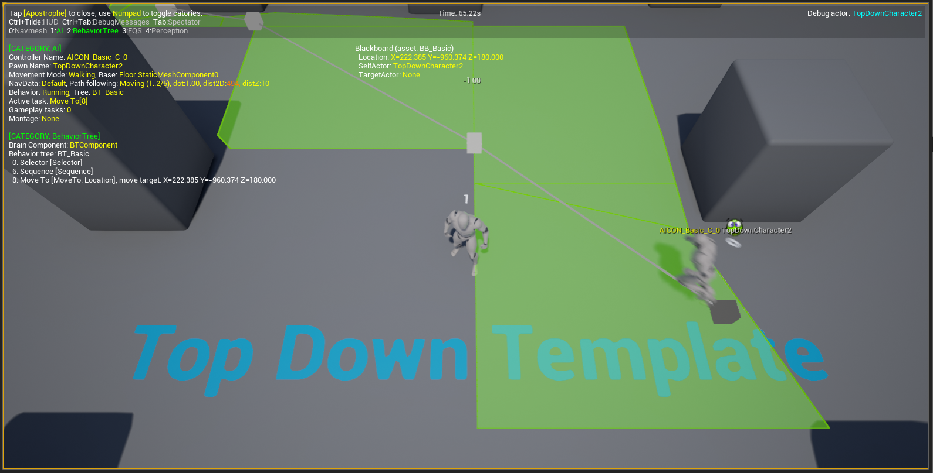
    - Press ( ‘ ) during to bring up AI debugging tools. In this screenshot you can see how the portions of the Nav Mesh that The Character runs through are cut up.
  - Nav Modifier Volume
    - Modifies the nature of the navigation mesh in an area.
    - Navarea classes increase weight to cross.
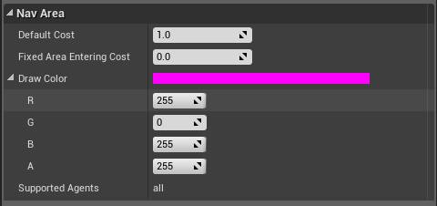
- Perception
  - Includes multiple senses, with the ability to create more
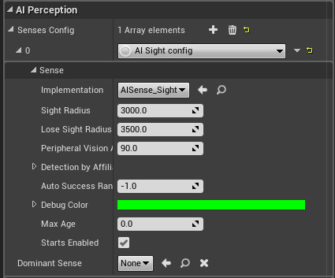
  - Event calls are on update for sense
- The Behavior Tree
  - The Blackboard
    - The blackboard acts a location to store variables for the behavior tree.
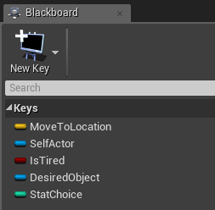
  - Components of the tree
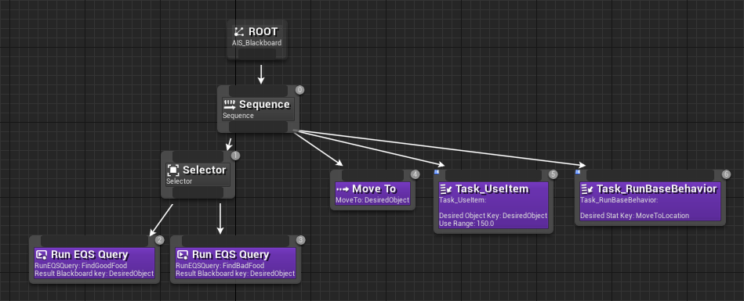
    - Branch nodes
      - Composite
        - Selector / Sequence
          - Selector nodes succeed on their first success, and fail at the end of their subtrees.
          - Sequence nodes fail on their first fail, and succeed at the end of their subtrees.
        - Simple Parallel nodes
          - Two children - A (a single task) and B (a full subtree)
          - While doing A, do B as well.
            - A is primary, B is secondary or filler.
      - Service
        - An implementation of parallel nodes that are designed to be less confusing.
        - Makes aborting subtrees much easier.
        - Less performance intensive
    - Leaf Nodes
      - Decorators ( aka - Conditionals)
        - Act as conditionals for subtrees
        - In traditional trees, conditionals were the first leaf nodes before actions. UE4 has decorators to make the tree easier to read.
        - Usually start by overriding existing decorator functions
          - The return nodes take boolean
      - Task
        - The actions that the AI agent should take
        - Regular blueprints, but require working off of references to the agent/controller.
        - Can have decorators attached
- The Environment Query System
  - “...for collecting data on the environment, asking questions of the data through Tests, then returning then one Item that best fits the questions asked.”
  - The purpose of the EQS is to allow the AI to make smart decisions about its environment.
  - Currently, must be enabled through Edit Menu > Editor Preferences > Experimental > AI > Environmental Querying System
    - Everything works properly in C++, but the blueprint interface is still under development, and may be unstable
  - EQS Testing Pawn
    - Specialized Pawn to check the status of an Query
    - Still in testing - Clear query while modifying
    - Color coded spheres (for your convenience)
      - Green - Red
        - Green is more desirable
        - Blue failed the check
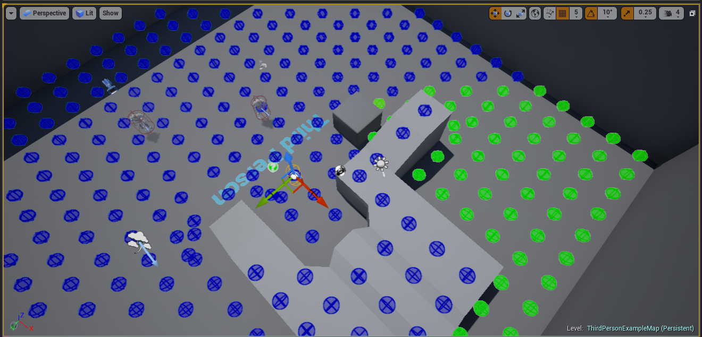
  - Run queries through the behavior tree “Run EQS Query” Node.
  - The Query
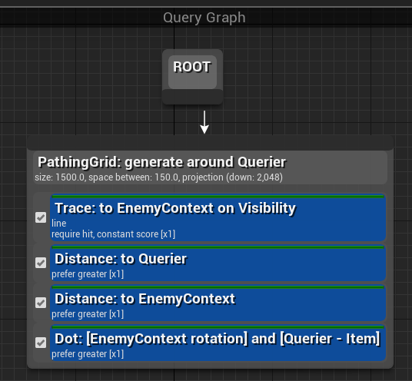
    - Query Generator
      - Nodes for the query.
      - Determine how the query will find an answer (such as using the nav-mesh, comparing all instances of a class, or checking line of sight.)
    - Tests
      - Act as conditionals for the query - appearance is the same as decorators for the behavior tree.
      - Compares some value (distance, dot product, etc)
    - Contexts
      - From what are the queries being measured?

Videos Referenced
Getting Started with AI | Live Training | Unreal Engine
https://www.youtube.com/watch?v=nshHCycft4A&t=4238s

Basics of AI | Live Training | Unreal Engine
https://www.youtube.com/watch?v=evYE7tfWXUY&t=2860s

Setting Up Advanced AI | Live Training | Unreal Engine
https://www.youtube.com/watch?v=NZZtMNdJk5o

Creating AI in UE4 Part 1 - AI Components
https://www.youtube.com/watch?v=n8cz5eE141Q&list=PLbRBWFaQHaW__LcCtV-KnqqgIFOyyFhr5

Making Game Ready AI | 01 | Live Training | Unreal Engine
https://www.youtube.com/watch?v=PgxuaTSkyu4&list=PLRrOfLSL-UhRBZ3bAFGAM4DS468pGWDrl

