Table of Contents
Project Overview 2
Top Level Functions 3
ResultT (Enumeration) 5
PlayerT (Structure) 6

Project Overview
This project is to implement an interactive text based version of the game Hi-Ho Cherry-O! This game is played with four players, either human or computer. The implementation will involve enumerated types, structures and an array of players.

Structure Chart
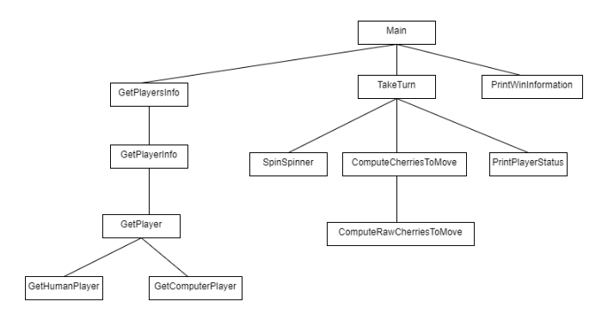

Top Level Functions
The main logic simulates the playing of a game.
This program, will use an array of players.
Main
Narrative: For each round, allow players to take a turn until a winner is found.

Get Players Info
While not done with the game
For each player
Take a turn
If the player has collected all ten cherries
Finished is true
Print the current status of the game
Print the winning statement

Function: GetPlayersInfo
Narrative:
Input: An uninitialized array of players.
Output: The array of players with all players initialized.

For each player
Set computer players to 0
GetPlayerInformation(player, computerPlayers)

Function: GetPlayerInformation
Narrative:This will get the information for an individual player
Input: The empty player structure and the number of computer players
Output: The completed player structure

GetPlayer using the player function
If the player is a computer, increment the computer players by 1.

Function: PlayerTakeTurn
Narrative: This function will allow a player to take a trun.
Input: The player
Output: The modified player

Spin the spinner
Compute the number of cherries to move based on the player’s bucket and the result of the spinner
Move the correct number of cherries.

Function: ComputeCherriesToMove
Narrative: Compute the number of cherries to move based on the spinner and the bucket.
Input: A spinner result, the number of cherries in the plyer’s bucket.
Output:The number of cherries to move.

Move = GetRawResultMove
If the spiner is spill bucket
Move = bucket
If bucket is less than 2 and move is -2
Move = bucket
If bucket + move > 10
Move = 0

Return move

Function: GetRawCherriesMove
Narrative: Compute the raw result move
Input: A spinner result,
Output:The number of cherries to move.

This is a big case statement.
If the result is bucket,
return -10
If the result is bird or dog
return -2
Otherwise return the number of cherries.

ResultT (Enumeration)
ResultT will describe the outcome of a spin on the spinner.
Properties
A ResultT may be
ONE_CHERRY BIRD
TWO_CHERRIES DOG
THREE_CHERRIES SPILL_BASKET
FOUR_CHERRIES UNKNOWN

Behaviors
Convert a ResultT to a string.
Convert an integer to a ResultT
Generate a random ResulT

Special Considerations
Create a constant, NUMBER_OF_RESULTS that represents the number of possible results.

Function: ResultTToString
Narrative: Provide a string for the given ResultT
Input: A ResultT
Output: A string

Just a large switch/case statement that assigns the correct string to a resultT

Function: IntToResultT
Narrative: convert an integer to a ResultT
Input: an integer.
Output: a ResultT

Cast the given integer to a result.
This will map the integer into the proper range using the mod function.

Function: RandomResulT
Narrative: This will generate a random result uniformly distributed between all values except UNKNOWN which will not be included.
Input: None
Output: A random result.

Generate a random integer between 0 and NUMBER_OF_RESULTS-1
Return the value of this using IntToResulT

PlayerT (Structure)
This structure represents a player in the game.
Properties
The player’s name. A simple string
The player’s type (Human or Computer)
The count of cherries in the player’s bucket, an integer.

Behaviors
Print a player
Get Player
Get a human player
Generate a computer player

Function: Print Player
Narrative: This will print information about a player
Input: The player structure
Output: None

Print the player name, type and bucket count.

Function:GetPlayer
Narrative: This function will ask for details about a human player.
Input: The number of computer players so far
Output: A completed player structure
A modified number of computer players

Set bucket to 0
Ask for type
If type is human
GetHumanPlayer
Else
GetComputerPlayer

Function:GetHumanPlayer
Narrative: This function will ask for details about a human player.
Input: A partially completed player structure
Output: The completed structure

Get the human player name from the player
Set the type to be human

Function:GetComputerPlayer
Narrative: This function will set the details for a computer player
Input: A partially completed player structure
The current number of computer players
Output: The completed structure

Get the name based on the number of computer players so far
Set the type to be computer.

