Table of Contents
Project Overview 2
Top Level Functions 3

Project Overview
The purpose of this project is to write a program which can compute simple statistics about several files. The project will read commands from a user supplied master file, perform the computation and print the output to the screen.
There are multiple error conditions to consider.

Structure Chart
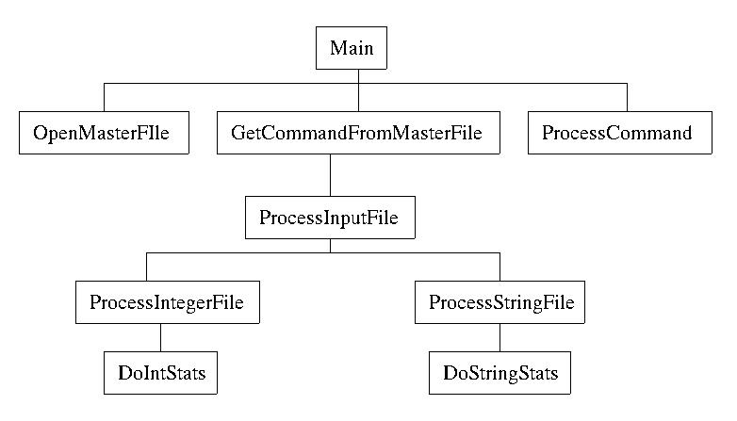

Top Level Functions
The main function needs to control the master file. Opening, retrieving information and closing. Responsibilities for processing the sub files will be deferred to another set of functions.
Main
Narrative: The routine should open the master file, read the commands and pass these to the appropriate routine.

Open the master file.
Get a command from the master file
while not at the end of the commands
Process the command
Get a command from the master file
Close the master file.

Function: OpenMasterFile
Narrative: This function will request the file name from the user and open the master file. If there is an error , this will be detected.
Input: none
Output: A input file stream, either open or in error

Prompt the user for the master file name
Read in the name
Attempt to open the file
if not successful
Print error message

Function: GetCommandFromMasterFile
Narrative: This function will read a single line from the master file.
Input: The open master file stream
Output: The file to process, a string,
The type of the file, a string
The type of operation, a character

Read the file name from the master file.
Read the type from the master file
Read the operation from the master file

Function: ProcessCommand
Narrative: This is the high level routine to process a command. It will attempt to open the data file. If successful, it will call the routine to process the file, otherwise it will print an error message.
Input: The file name, a string
The file type, a string
The operation, a character.
Output: None

Open the input file
If success
Process the input file
else
print an error.

Function: ProcessInputFile
Narrative: This will decide the intermediate level function to call
Input: An open input file, a file stream
The file type, a string
The operation, a char
Output: None

If type is Integer
ProcessIntegerFile
else if type is String
ProcessStringFile
else
report an error

Function: ProcessIntegerFile
Narrative: This function will decide what low level integer function to call.
Input: An open file stream
A character representing the operation to perform
Output: none

DoIntStats
If the size is 0, print error
else
If the operation is count
Print count
if the operation is max
Print max
if the operation is min
PrintMin
if the operation is average
Print sum/count
if the operation is sum
Print sum
else
print error function unknown.

Function: DoIntStats
Narrative: This function computes all of the stats on an integer file
Input: An open file stream
Output: The count of the data in the file, an integer
The sum of the data in the file, an integer
The maximum value in the file, and integer
The minimum value in the file, an integer

read in the first value
max = first value
min= first value
sum = first value
count = 0
while the read was successful
increment count
max = maximum(max, value)
min = minimum (min, value)
sum += value
read in the next value

Function: DoStringStats
Narrative: Same as DoIntStats, but will not compute sum. It will compute longest and shortest.
Input:
Output:

See above

Function: ProcessStringFile
Narrative: Same as ProcessIntFile but will use strings.
Input:
Output:

SeeAbove

