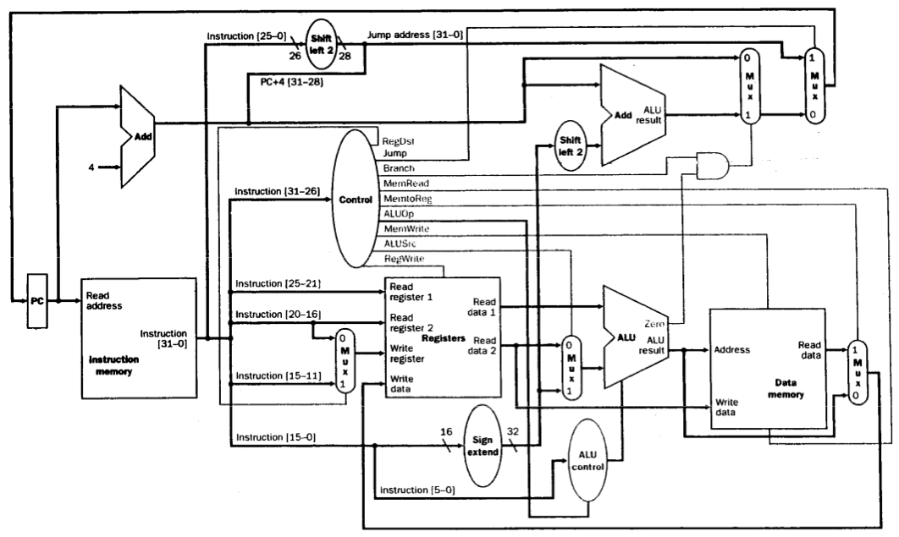

|  |  |  |  |
| --- | --- | --- | --- |
| Control Line | Value | Control Line | Value |
| RegDest |  | MemWrite |  |
| Branch |  | ALUSrc |  |
| MemRead |  | RegWrite |  |
| MemToREg |  |  |  |