Unreal Engine's Skeletal and Animation Retargeting System

Unreal Engine's Skeletal and Animation Retargeting System is a useful tool that allows one skeletal mesh asset to clone the animations that have already been defined for another skeletal mesh asset. The net effect is that the new asset will mimic the movements of the old asset. This is an extremely useful tool for, not just for developers who make use of assets created by talented artists and animators, but it can also be a great time-saver for those same asset creators.
When searching on the Unreal Marketplace or elsewhere for skeletal mesh, character, or animation assets to use, there are a few details to look for in any accompanying documentation or descriptions. Is the asset scaled to the Epic Skeleton? Is the asset rigged? Is the asset rigged specifically to the Epic skeleton? Is the asset already animated? If the asset is scaled to the Epic skeleton, it means that the asset is sized to fit in the same context as Epic's default mannequin. So, for example, an airplane asset scaled to the Epic skeleton would be the appropriate size for any character also scaled to the Epic skeleton to fit inside of it. A rigged asset is one that has the potential to be animated. If the asset is not rigged, it cannot be animated or make use of the retargeting system. An asset that is rigged specifically to the Epic skeleton is one that can be used very easily with the retargeting system as it shares all of the same bones as the default Epic skeleton. Finally, an asset that does not have animations that come with it will have to either have animations created manually for it, or use the retargeting system to create animations. An asset that already has animations is useful, and new animations can also be added to its repertoire via the retargeting system without overwriting or erasing existing content.

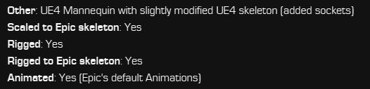
1 An asset that is already scaled, rigged, and animated to Epic's default mannequin skeleton.
(polyphoria, 2018)

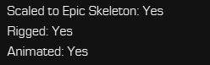
2 An asset that is scaled to the Epic default mannequin skeleton, but is rigged to its own skeleton, and has its own animations.
(Unreal Engine/Epic Games, 2018)

Another detail of Skeletal Mesh assets of which to take note is that they are not version-dependent. This means that if you are working in, for example, version 4.23 of Unreal, and the skeletal mesh asset which you wish to use is labeled only up to version 4.21, it can still be used with version 4.23. Though, the Epic Launcher will not allow you to add the 'outdated' asset via the 'Add To Project' button. First you must create a new project in the version listed for the 'outdated' asset. Once this is created, it can be migrated to your project that uses the newer version of Unreal. (PO-Art, 2017) This, of course, may be invalidated by a major update of the Unreal Engine, such as if a version 5.XX is released, but among 4.XX versions, this should hold true for the foreseeable future.
To begin understanding the Animation and Skeletal Retargeting System, it is useful to first become acquainted with the basic assets in Unreal. The three basic components for an animatable actor are the Skeletal Mesh, the Physics component, and the Skeleton component.
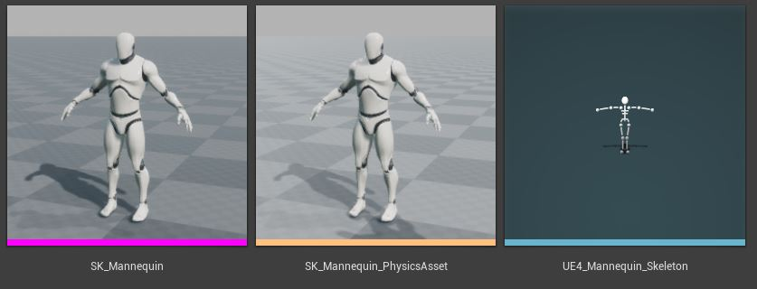
3 From left to right, Skeletal Mesh component, Physics component, and the Skeleton component.
(Unreal Engine/Epic Games, n.d.)

The Skeletal Mesh is the visible 3D component that forms the 'body' of the actor. The Physics component helps define how the actor will react in collisions, when falling, and in other physical interactions. It is not used in the retargeting system, but it is generally useful to be aware of, and recognize it. The Skeleton component defines the bones, and their relationships to each other. It is necessary so that assets can be rigged and then animated.
Double-clicking a Skeleton component will open Persona, Unreal's tool for editing animations. In the upper right corner, the user can switch between five different views; the Skeleton, the Mesh, the Animation, the Blueprint, and Physics. The default view will be the Skeleton, and this is the only one that will be relevant for the topic of Animation and Skeletal Retargeting. The Skeleton hierarchy with bone names will be in the left-most pane, a display of the Skeletal Mesh in the world will be in the center viewport, and a blank Details pane and a Anim Curves pane on the right side. Left-clicking on Character in the center viewport will bring up a pop-up menu, selecting Bones then, under Bone Drawing, selecting All Hierarchy will display the bone structure on the Skeletal Mesh in the viewport.
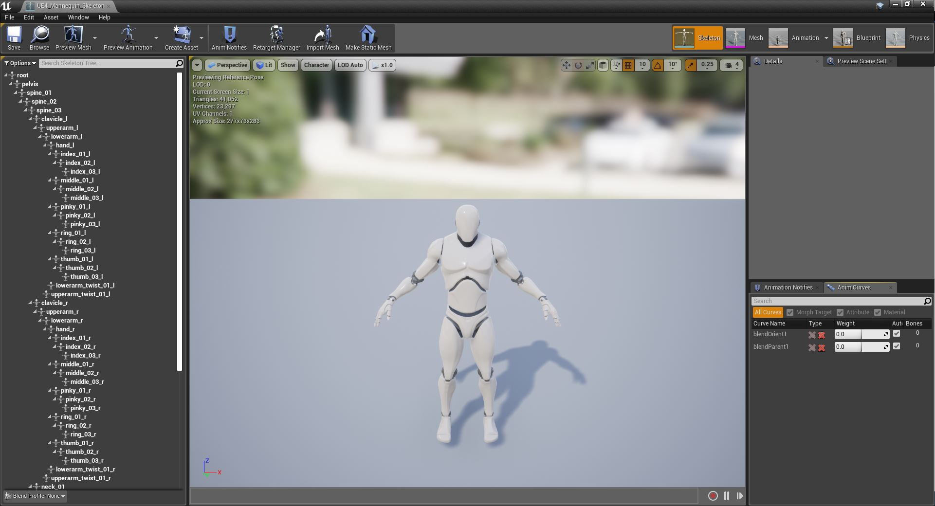
4 The Skeleton view of Unreal's default skeleton in Persona.
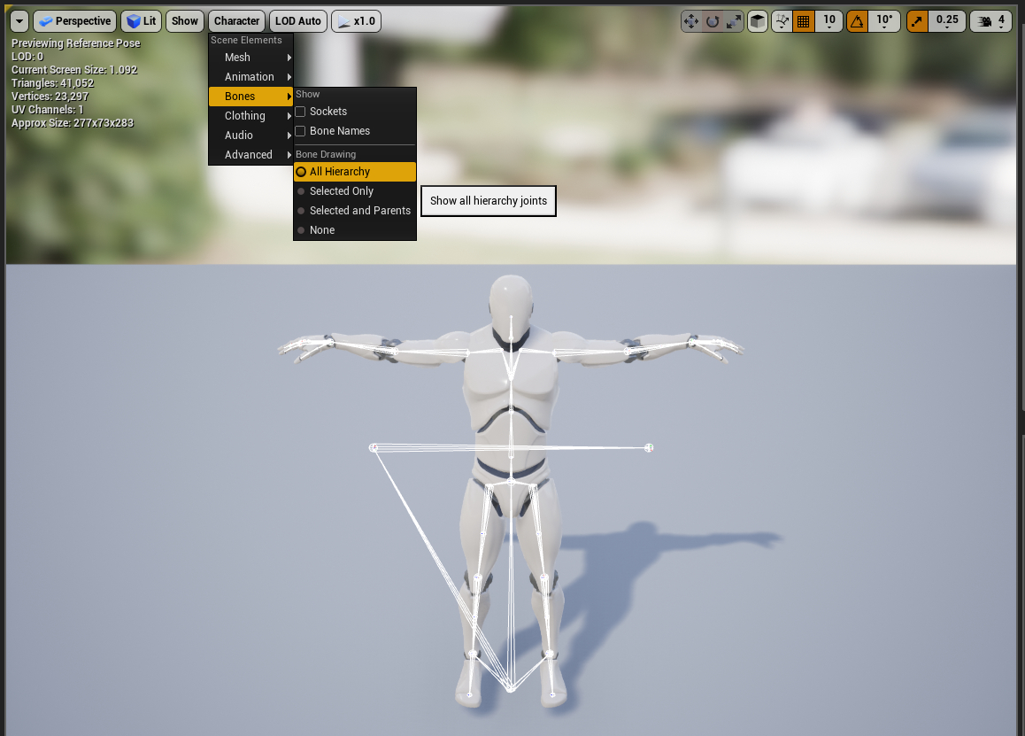
5 The current series of menus to show the bones in the viewport.
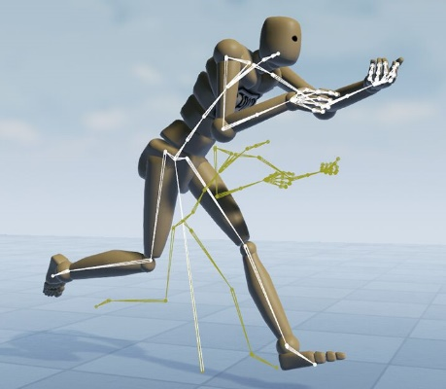
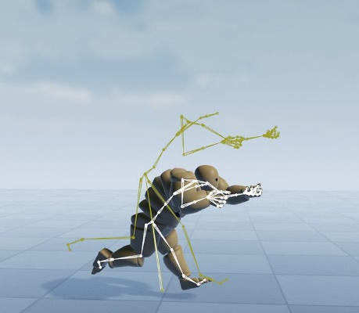
The same Skeleton component may be shared by different Skeletal Mesh components, even if they do not have the same body proportions. For example, a Skeleton designed for a normally proportioned Skeletal Mesh, such as the Epic default mannequin, could also be used with a Skeletal Mesh proportioned as a fantasy dwarf, or as a giant. Skeletal Meshes that share the same Skeleton component can share the same Animation assets directly, as the Animations are tied to the Skeleton component. However, to appear properly, their skeletons must be retargeted in Persona.
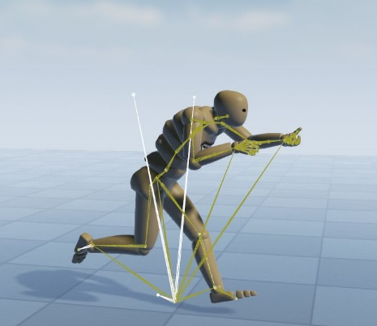
6 These three characters all use the same Skeleton component, but are proportioned differently. To get the latter two to appear correctly, their skeletons must be retargeted.
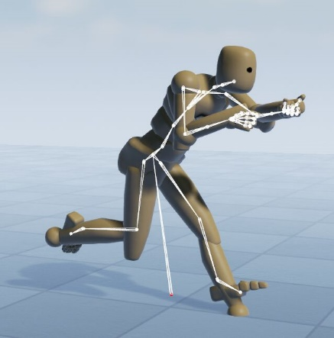
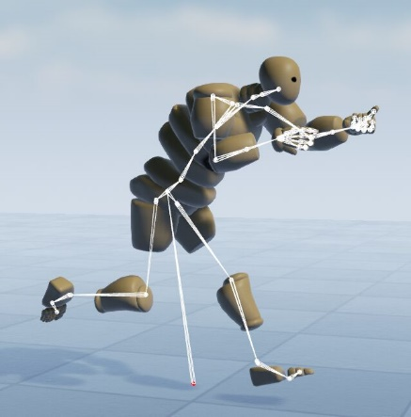
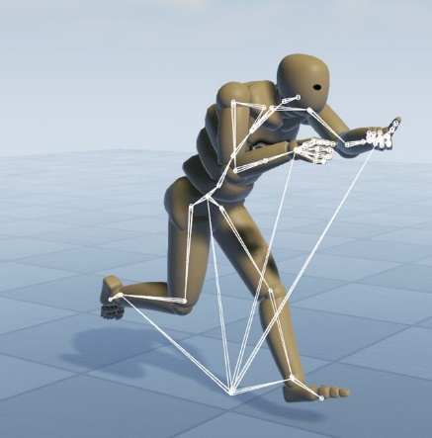
(Unreal Engine/Epic Games, 2004-2020)
7 This is how those same Skeletal Meshes would appear before their skeletons were retargeted.

To accomplish this, click on the Options drop-down menu in the upper-left corner of the skeleton hierarchy pane, and select 'Show Retargeting Options'. Hovering your mouse anywhere over the new options that have appeared under the 'Translation Retarget' column, and pressing Ctrl+Alt will bring up a handy tool tip that includes a suggested work-flow:

1). Right-click on your root bone and recursively set all bones to Skeleton
2). Find the Pelvis or equivalent bone and set that to AnimationScaled
3). Find the Root bone, and IK bones, any weapon bones, or other marker-style bones and set them to use Animation.
(Unreal Engine/Epic Games, 2015)

Very important: Be sure to save your skeleton when prompted at each step in the process!
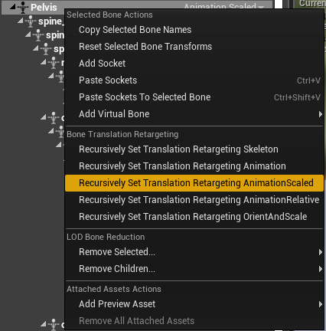
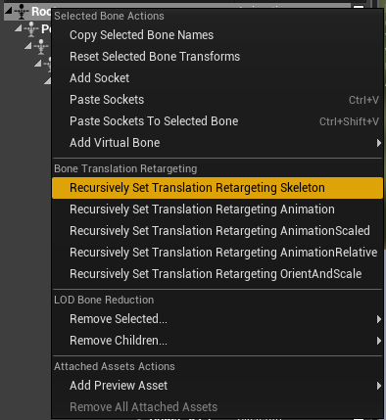
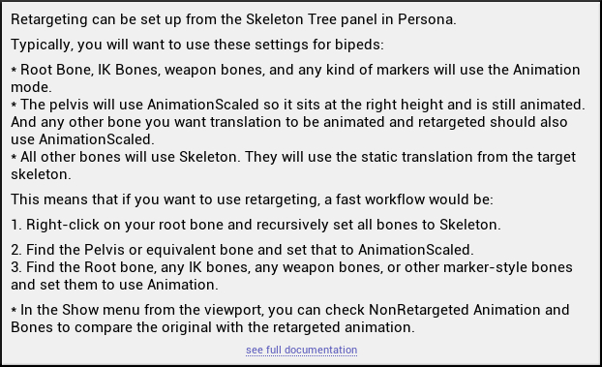

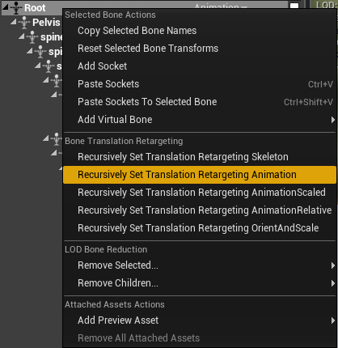

The differently-proportioned Skeletal Mesh should now appear and behave correctly.

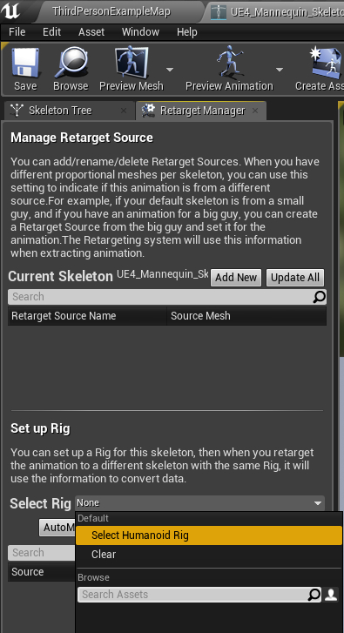
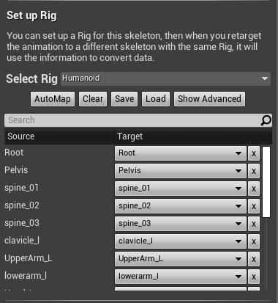
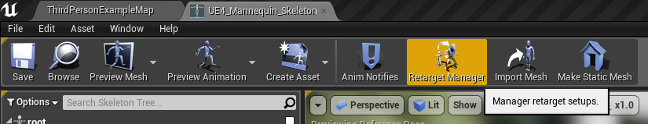
To use animations with a Skeletal Mesh that has a completely different Skeleton, the Animations need to be retargeted. The first step in this process is to create an object called a 'Rig'. This should not be confused with the rigging done in the normal animation process. The Retargeting Rig acts as a middle-man between the Skeleton component of the source asset, and the Skeleton component of the target asset. To create a Retargeting Rig, open the Skeleton component of the source asset. Go to the Retarget Manager in the top pane of the screen. The Retarget Manager will open in the left-hand pane of the screen, pushing the skeleton hierarchy behind it. Next, from the drop-down menu next to Select Rig, click Select Humanoid Rig. It is unclear as to whether or not this would be what one would select if attempting to use the retargeting system for non-humanoid actors, such as a fox, or a vehicle. When I checked the options on a quadrupedal fox asset, it still gave just the Humanoid Rig option. The bone information will be automatically populated into the Retargeting Rig. Save your source Skeleton, and you can close the window.

The next step will be to open your target's Skeleton component. The Retargeting Manager should already be open in the left-hand pane, but if not, open it from the button on the top pane, as before. Select Humanoid Rig again from the drop-down menu. If the target's skeleton hierarchy has used the same naming conventions as your source's skeleton hierarchy, these will automatically populate and match bones from the source to the target. However, if your target's skeleton uses different names for the bones, then you will need to go down the list manually, and match the bones of your target skeleton to the bones of the source skeleton in the Retargeting Rig.
Note that by default, only the major bones are shown in the rig. To show and assign smaller bones, such as fingers, click the Show Advanced button on under the Setup Rig section. Once you are happy with the Retargeting Rig setup in your target's Skeleton, save and close the window.

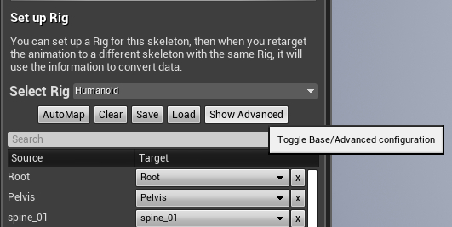

Now you are finally ready to retarget the animations! Locate the animation belonging to your source asset that you wish to clone. There are several different types of animation objects. Like most objects and components in Unreal, these are color-coded to help you recognize them easily. Orange animation objects are Animation Blueprints. These contain a sophisticated web of Animation Sequences, which are tied to input actions, events, and other stimuli that tell the Skeletal Mesh when to display a particular animation. These are important, but properly covering them would be a topic for a whole other report. The lighter orange animation objects are Blend Spaces which transition from one Animation Sequence to another. For example, when an actor transitions from standing still to running. Finally, the green color-coded animation objects are Animation Sequences. These are the ones that we are interested in for the purposes of Retargeting.
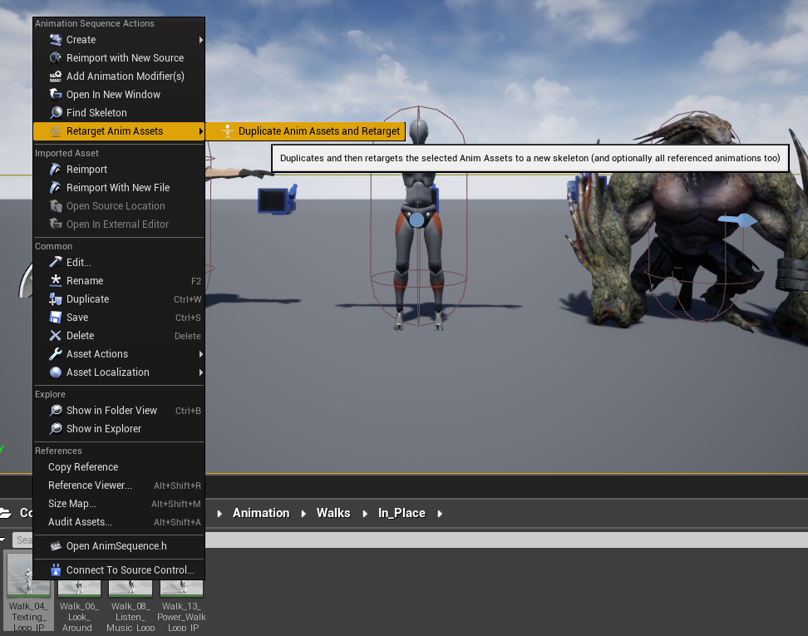
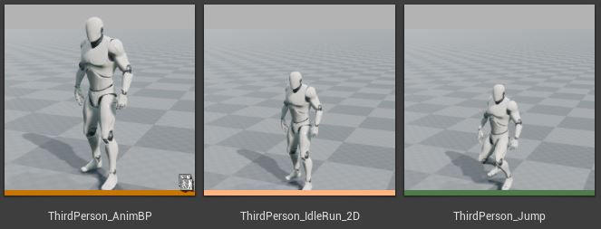
Right-click on the Animation Sequence that you wish to clone. Select Retarget Anim Assets -> Duplicate Anim Assets and Retarget from the pop-up menu. This will bring up the Select Skelton window. The source skeleton will already be chosen because of the Animation Sequence which you are cloning, so in this window, you are only selecting the target Skeleton from a list of all of the Skeleton assets in your project.
8 Once you have a Retargeting Rig set up, right-click on the source's Animation Sequence that you wish to clone and select the Retarget Anim Assets option.
9 From left to right, an Animation Blueprints, a Blend Space, and an Animation Sequence object in Unreal.
There are a couple of things of which to take note in the Select Skeleton window. First, when you highlight your target skeleton from the list, there should be a character showing in each of the panes to the right. If one is empty, that means that a Retargeting Rig has not been properly set up for that Skeleton component. Secondly, the poses of the two characters should match. Usually, characters are in one of two poses; an 'A' pose, or a 'T' pose; named for how their arms are hanging at their sides. If the poses do match, click the Retarget button in the lower left of the Select Skeleton window, and you're done! A new Animation Sequence asset will be created in your main Content folder. It will have the same name as the source Animation Sequence, so rename it and move it to an appropriate folder for your target's animation assets. If the poses do not match, then cancel the Select Skeleton window, and reopen your source Skeleton component.
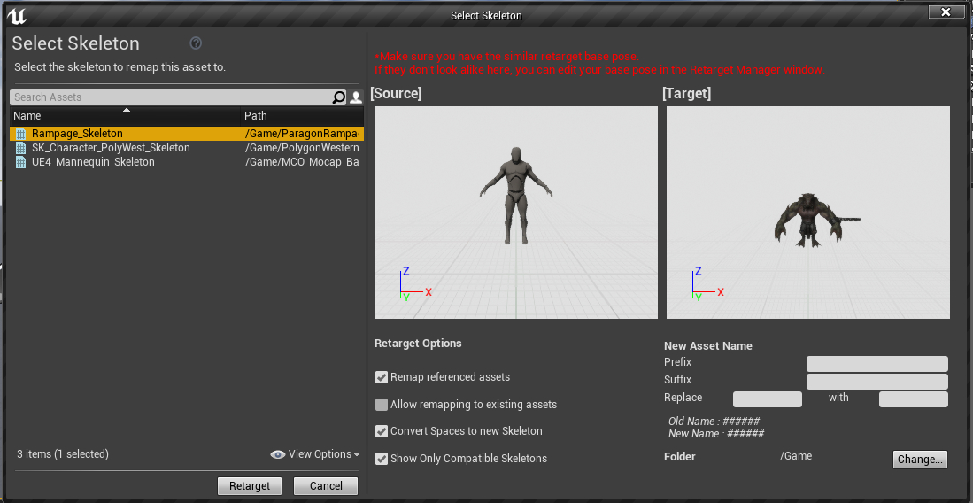
10 The Select Skeleton window. Both the source and the target are in the A pose. You're good to go!

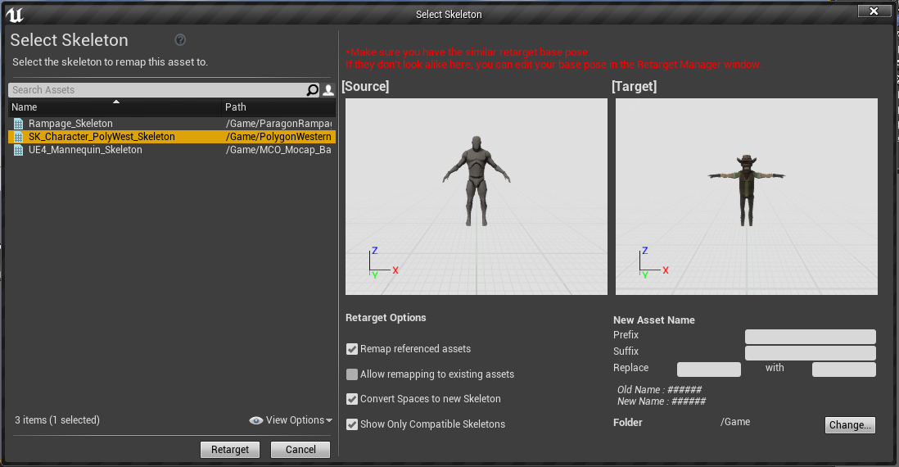
11 The source is in the A pose, but the target is in the T pose. You need to go back to the source's Skeleton component, and adjust the pose!
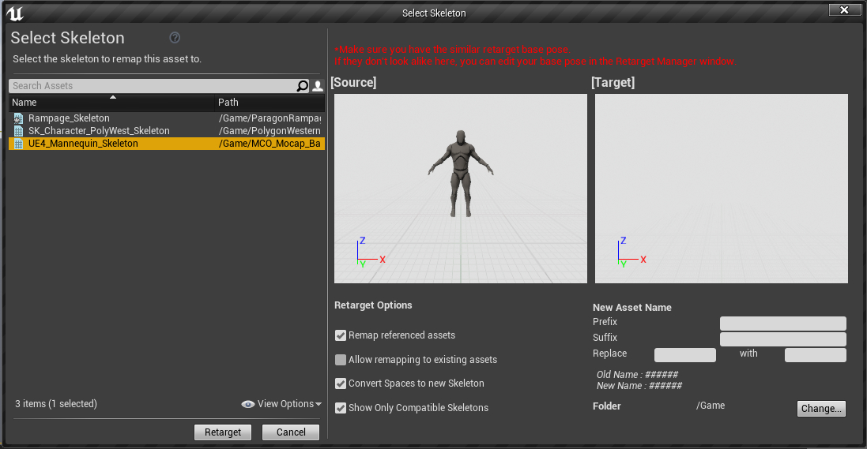
12 The source Skeleton has a properly defined Retargeting Rig, but the selected target Skeleton does not!

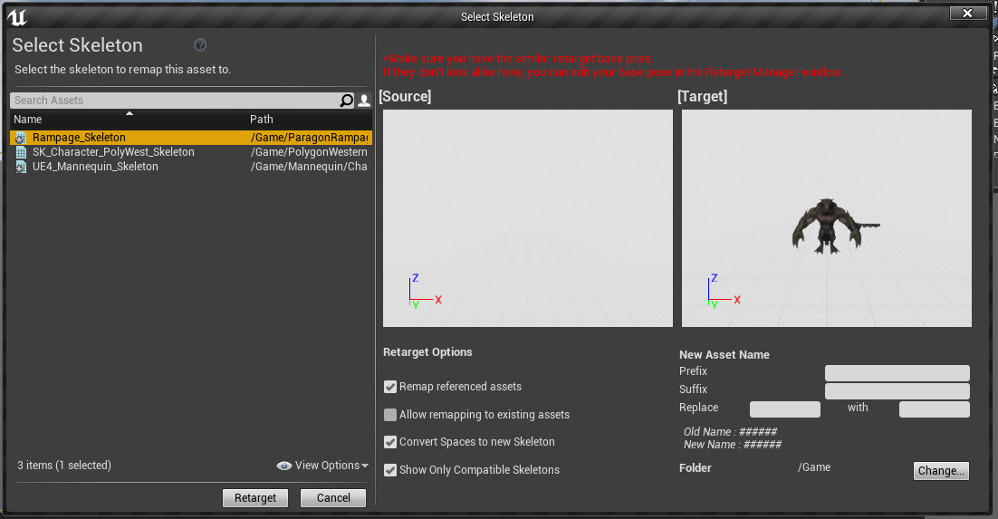
13 The target Skeleton has a properly set-up Retargeting Rig, but the source Skeleton does not!
To adjust the pose of the source Skeleton so that it will be compatible with that of the target Skeleton, head back to the source Skeleton component, and reopen the Retargeting Manager, if it is not already open. In the viewport you can click on the individual joints and bones to rotate and adjust them as needed. Make sure that the poses match as best as possible. If the elbows of your target Skeleton are straight, so should your source Skeleton's be. When you have finished adjusting the pose of your source Skeleton, at the bottom of the left-hand pane, there should be a Manage Retarget Base Pose section, and Modify Pose and View Pose buttons. Click the Modify Pose button. This will bring up a pop-up menu, select the Use Current Pose option. Save the Skeleton and close the window. If you return to this Skeleton component later, it will appear to be in its original pose again. Simply click the View Pose button, and you should see it in the pose that you defined earlier. This pose is only used for new retargeted animations, and does not affect the animations of the source Skeleton, or other retargeted animations that were previously created. If you wish to later retarget to a Skeleton that uses a pose the same as the original source pose, then all you have to do is select Reset from the Modify Pose pop-up menu, and the source Skeleton's retargeting pose will revert the original.
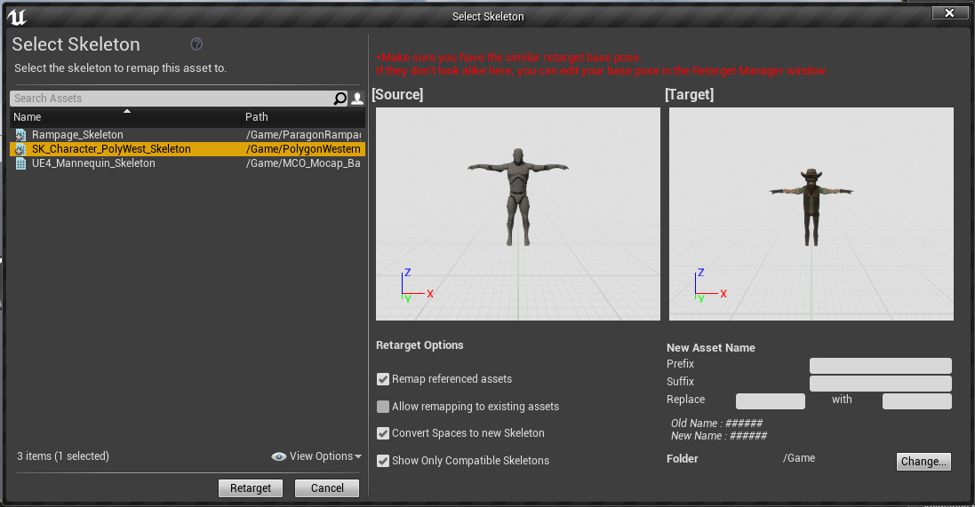
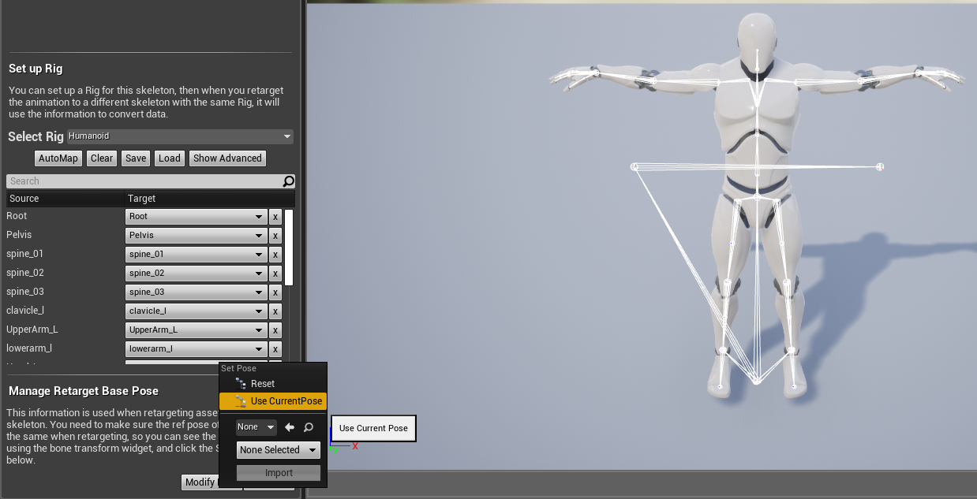
Return to the source Animation Sequence that you wish to clone, right-click and select Retarget Anim Assets as before to get to the Select Skelton window again. Now you should see your source asset and your target asset sharing the same pose in the view panes.
14 The poses now match. Click Retarget to create your new Animation Sequence for the target Skeleton!
15 The current method to save the retargeting pose.
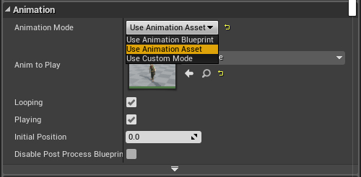
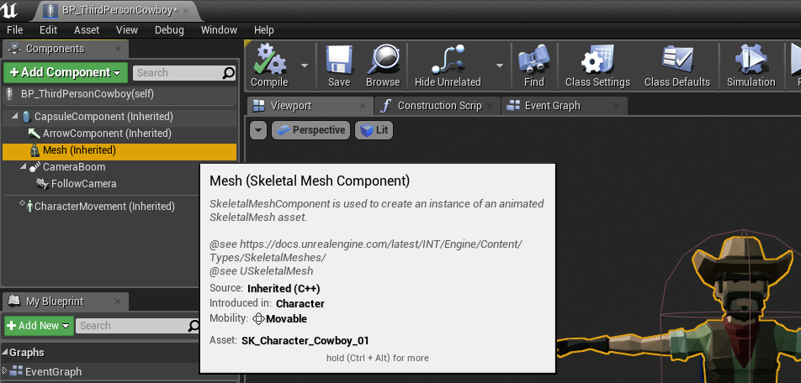
To quickly test the new Animation Sequences that you have created in a test character, you can open up your character blueprint, select the Mesh component from the left hand pane, and then in the Details pane on the right-hand side, under the Animation roll-out, change the Animation Mode from Use Animation Blueprint to Use Animation Sequence. Just below it, you will see the Anim Class change to Anim To Play, with a drop-down that will show only Animation Sequences defined for the Skeleton component associated with the Skeletal Mesh your character is using. Among them should be the new Animation Sequence you have just created! To use the Animation Sequences in a more comprehensive way, as part of an Animation Blueprint is a topic for another report, but there is an Animation learning module in Unreal's learning portal, as well as in the Unreal Documentation pages.
16 Assigning the Animation Sequence in a character blueprint to test the new animation.

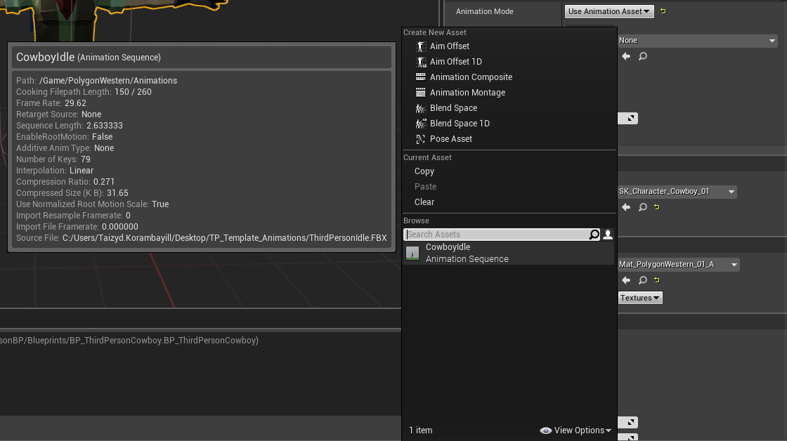

References and Assets Used in Demonstration
MoCap. (2018, November 5). MCO MoCap Basics by MoCap Online. Retrieved from Unreal Engine Marketplace: https://unrealengine.com/marketplace/en-US/product/28fc3cc4332541e3b0037d67a65e5d6d
PO-Art. (2017, June 20). Feline Swordsman by PO-Art. Retrieved from Unreal Engine Marketplace: https://unrealengine.com/marketplace/en-US/product/feline-swordsman
polyphoria. (2018, December 3). Western NPC by polyphoria. Retrieved from Unreal Engine Marketplace: https://unrealengine.com/marketplace/en-US/product/western-npc
Synty Studios. (2018, April 2). POLYGON - Western Pack by Synty Studios. Retrieved from Unreal Engine Marketplace: https://unrealengine.com/marketplace/en-US/product/polygon-western-pack
Unreal Engine/Epic Games. (2004-2020). Animation Retargeting | Unreal Engine Documentation. Retrieved from UnrealEngine.com: https://docs.unrealengine.com/en-US/Engine/Animation/AnimationRetargeting/index.html
Unreal Engine/Epic Games. (2015, September 28). Skeleton Assets: Anim Retargeting Different Skeletons | 03 | v4.8 Tutorial Series | Unreal Engine - YouTube. Retrieved from YouTube.com: https://www.youtube.com/watch?v=xy9aLbZLdeA
Unreal Engine/Epic Games. (2015, September 28). Skeleton Assets: Importing, Sharing Skeletons & Anims | 02 | v4.8 Tutorial Series | Unreal Engine - YouTube. Retrieved from YouTube.com: https://www.youtube.com/watch?v=JkcJ5bjGPsg
Unreal Engine/Epic Games. (2015, September 28). Skeleton Assets: Overview | 01 | v4.8 Tutorial Series | Unreal Engine - YouTube. Retrieved from YouTube.com: https://www.youtube.com/watch?v=FDbpHamn2eY
Unreal Engine/Epic Games. (2015, September 28). Skeleton Assets: Using Sockets | 04 | v4.8 Tutorial Series | Unreal Engine - YouTube. Retrieved from YouTube.com: https://www.youtube.com/watch?v=DyPq1-JGMKY
Unreal Engine/Epic Games. (2018, March 8). Paragon: Rampage by Epic Games. Retrieved from Unreal Engine Marketplace: https://unrealengine.com/marketplace/en-US/product/paragon-rampage
Unreal Engine/Epic Games. (n.d.). Third Person Template - Unreal Engine Launcher. Retrieved from Epic Games Launcher.
Ying Pei Games. (2014, September 13). Prototype Characters by Ying Pei Games. Retrieved from Unreal Engine Marketplace: https://unrealengine.com/marketplace/en-US/product/prototype-characters

