Table of Contents
Project Overview 2
Top Level Functions 3
ActionT (Enumeration) 8
BookT (Structure) 9

Project Overview
This program simulates a simple library. There is a basic database that contains information about books and another containing information about readers. The program allows readers to check out and return books. In addition, simple statistics on the books and readers are collected.

Structure Chart

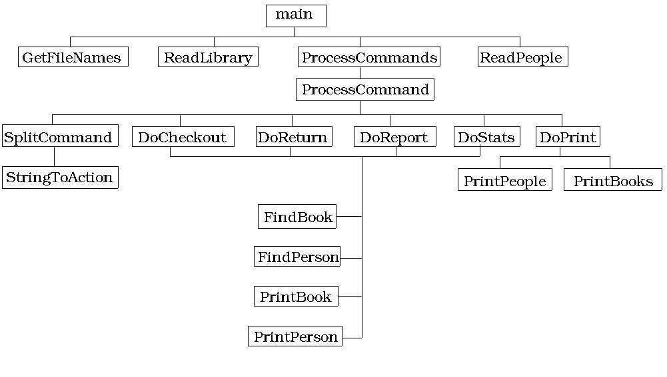

Top Level Functions
Main
Narrative: This is an extremely high level function which just calls the component parts.
The program employed two arrays. Both are static and of fixed size. One represents the books in the library and the other the readers. These are called the library databases.

Get the file names
Read in the library
Read in the people
Process the commands.

Function: GetFileNames
Narrative: Get the master file name from the user, and return the names for each of the database components.

Input: None
Output: Three strings, the names of each of the database files and the command files.

While the user does not provide a valid file name.
Prompt the user for a file name.
Read the database and command file names from the user supplied file.
Return these names.

Function: ReadLibrary
Narrative: This function reads in the books stored in the book database. Note this function may produce errors if the book file is unavailable or the book file contains too many books.
Input: The name of the book database file.

Output: An array of books and the count of books in the library.

Open the book file
If unable to open the file
report an error
Otherwise
for each line in the file
Read the book and add it to the library
If there is no room
Report an error.

Function: ReadPeople
Narrative: This function reads in the people stored in the reader database. Note this function may produce errors if the reader file is unavailable or the reader file contains too many readers.

Input: The name of the reader database file.
Output: An array of books and the count of readers in the library.

Open the reader file
If unable to open the file
report an error
Otherwise
for each line in the file
Read the reader and add it to the library
If there is no room
Report an error.

Function: ProcessCommands
Narrative: This function will read and process the commands from the command file. It will produce an error if the file is not available.

Input: Command file name, library and person database.
Output: None

Open the command file
while there are commands
process the command

Function: ProcessCommand
Narrative: This function is responsible for processing an individual command.
Input: The command, and the library and person databases
Output: none.

Convert the command to an action.
Based on the action call the appropriate command processing routine.

Function: DoCheckout
Narrative: This routine will loan a book to a user if the user does not have a book, the book is in the library and the book is not checked out.

Input: The user, book and library databases.
Output: The updated library databases

If the reader does not exist (FindReader)
print an error
If the book does not exist (FindBook)
print an error
else
if the reader already has a book
print error
if the book is alreadychecked out
print an error
else
loan the book to the user

Function: DoReturn
Narrative: This routine attempts to return a book. It will produce errors if the book is not checked out or if the book does not exist.

Input: The book title and the library databases
Output: The modified databases

Find the book (FindBook)

If it is not present
print an error
If it is not checked out
print an error
else
remove the book from the user
return the book
update statistics.

Function: DoReport
Narrative: This routine will print information about a reader.
Input: The reader’s name and the library databases
Output: none

Find the reader
If they exist
PrintPerson
else
print an error message.

Function: DoStats
Narrative: This routine will print the stats for a book.
Input: The book title and the library databases
Output: none

Find the book
If the book exists
PrintBook
else
print an error

Function: DoPrint
Narrative: Prints either all of the books or all of the readers.
Input: The command along with the library databases.
Output:

If cmd is Books
PrintBooks
else
PrintPeople

Function: FindPerson
Narrative: This is a linear search of the person database
Input: The person name and the book array
Output: The position of the person, NOT_FOUND

Linear search.

Function: FindBook
Narrative: This is a linear search of the book database
Input: The book array and the book’s name.
Output: The position of the book or NOT_FOUND

Linear search.

Function: PrintPerson
Narrative: Prints a formatted report describing a person
Input: The record for a person
Output: None

Function: PrintBook
Narrative: Print a formatted report describing a book.
Input: The record for a book
Output: None

Function: PrintBooks
Narrative: Prints all the books.
Input: The book array
Output: none

For each book
PrintBook

Function: PrintPeople
Narrative: Prints all of the people.
Input: The people array
Output: none

For each person
PrintPerson

ActionT (Enumeration)
This enumeration provides a list of all possible command actions.
Properties
Domain
CHECKOUT, REPORT, RETURN, STATS, PRINT, UNKNONW

Behaviors
One function that takes a string an returns the enumeration type.

Discussion:
none.

Function: StringToActionT
Narrative: This takes a string and returns the appropriate actionT.
Input: A string
Output: The corresponding action.

BookT (Structure)
This structure represents a book.
Properties
Title: a string
Author: a string
Page Count: an int
borrower: the index into the person array of the person holding the book.
ReaderCount: the number of readers who have read the book.
Present: a bool indicating if the book is present in the library.

Behaviors
none

Discussion:
none

PersonT (Structure)
This structure holds a person.
Properties
Name: a string
booksRead an int describing how many books the person has read.
PagesRead: the total number of pages read by this individual.
Book: an index into the book array
HasBook: a bool, true if the person has a book.

Behaviors
None

Discussion:
None

