Table of Contents
Project Overview 2
Top Level Functions 3
CodeDirT (Enumeration) 6

Project Overview
This program will encode and decode messages encrypted using a number of different ciphers. All messages to be encrypted are stored in the file codes.dat and all processing is done in batch mode.
This program will use an enumeration type to represent the direction to shift letters in the message.

Structure Chart

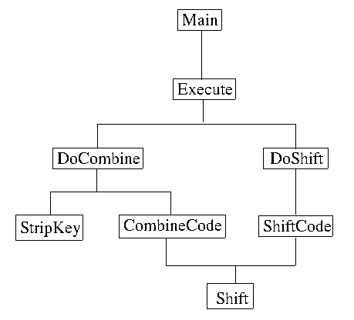

Top Level Functions
The program works by calling one of two encryption routines. They share a common underlying shift routine. In general the commands are decided in Execute, the parameters are configured the next level down and the individual lines are encrypted the next level down. (Do* vs *Code in the structure chart.)
All routines eventually call shift, which assures characters are properly shifted.

Main
Narrative: Mostly responsible for reading in a command and executing it.

Open datafile
Get command from datafile
while command is valid
Execute the command
Get command from datafile
close the datafile

Function: Execute
Narrative: This function performs the high level execution of the command
Input: Command to execute (only command, not the rest of the input)
Datafile
Output: none

Get the code type
Read in the key
Shift the key to lower case and strip all non alphabetic letters.
Based on the command and code type
read in appropriate parameters
execute the encoding
DoShift
DoCombine

Function: DoCombine
Narrative: Execute all of the combine encryption techniques.
Input: input file
key
direction of encryption
type of combine
Output: none

Get lines to encode
Print coding type and lines to encode
compute the shift amount based on the type and direction.
Call CombineCode with correct parameters for each line of code.

Function: CombineCode
Narrative: This function does the actual encoding based on the parameters
Input: The string to encode
The Key
The direction to Encode
Output: The encoded string

For each character in the messages
If the character is alpha
Save if the letter is uppercase
shift the lower case version of the letter based on the direction.
If the letter was upper case, change the shifted letter to upper case
add the shifted letter to the encoded message
else
add the character to the encoded message
return the encoded message

Function: StripKey
Narrative: This will change a string to all lower case letters, removing all non alphabetic characters.
Input: A string
Output: A string in the proper format

For each character in the input string
if it is alphabetic
add lower case version to output string
return output string

Function: DoShift
Narrative: Do the high level computations involved in a shift encryption
Input: The input file
Shift amount
Output: none

Get lines to encode
Print encryption and lines to encrypt information
for each line in the messages
read the line
encrypt the line
print out the encrypted line

Function: ShiftCode
Narrative: Encrypt an individual line
Input: The line to encrypt
The amount to shift by
Output: The encrypted line

for each character in the message
if the character is a letter
Add the shift of the letter to the message
else
Add the unshifted letter to the message
return the encrypted message

Function: Shift
Narrative: This function shifts an individual character by a given amount.
Input: The lower case character to shift
The amount to shift the character by.
Output: A shifted character remapped into the range a-z

Compute the current character position
Add the shift amount to the character position
If the position < 0 or > 26 bring back into that range.
Return the appropriate character.

CodeDirT (Enumeration)
This is used by the program to communicate the ways characters are shifted.
Properties
FORWARD, REVERSE, ALTFORWARD, ALTREVERSE

Behaviors
This enumeration has no behaviors.

Discussion:
CodeDirT is used to describe the direction to shift individual characters. There is no behavior.

